Procedure Name: | Cash Burn | 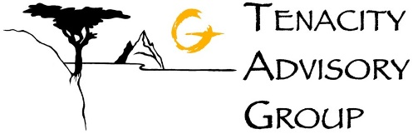
Department: | Investment Team
Effective Date: | 11/14/2022 | Author: | Katie Weinschenk

Description

This procedure will sell all non-model non-restricted holdings plus all cash in excess of the set model % and invests in model holdings.

Assumptions

N/A

Procedure

- In WMP, go into the account where the Cash Burn will take place
- Click on the Positions tab to review all holdings in the account

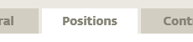

- If you would like to do a Cash Burn and the holdings are Restricted, go to the Controls tab

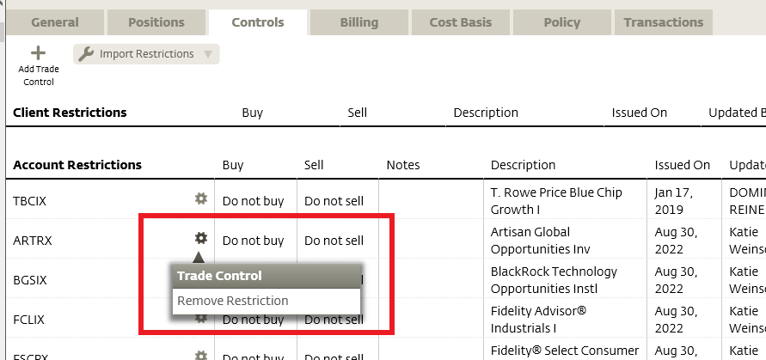

  - Click the gear next to the position you wish to sell and select Remove Restriction
  - WMP will ask you if you’re sure you’d like to delete. Select Yes.
  - Repeat this for any other position that needs to be sold from the model.
- Go back to the Positions tab
  - Click Generate Trades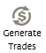
  - Select Cash Burn

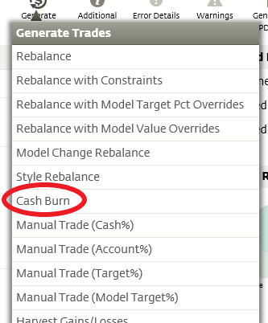

  - This will bring you to the Trade Settings page. Select Generate Trades
- Once the trades are Generated, click the account number in the upper-left corner

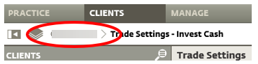

  - Click the Positions tab
  - Review the proposed trades
  - If everything is correct, click Manage Trades in the upper-right corner

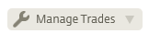
  - Under Trade Actions, click Submit Trades

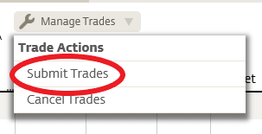

- This will generate an Execute Trades window

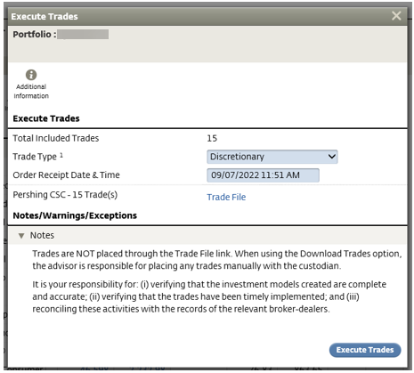

  - Click Execute Trades
- The Positions tab will now show the funds post-trades

References

N/A

Revision History

Revision Date | Revised By | Revision Notes
11/14/2022 | Katie Weinschenk | Procedure Created

