Procedure Name: | Depositing Physical Stock Certificates | 
Department: | Investment Team
Effective Date: | 11/14/2022 | Author: | Katie Weinschenk

Description

Occasionally, a client will have physical stock certificates they wish to deposit in a Pershing account. For Pershing to take possession of the certificates,

Assumptions

N/A

Procedure

- Open the appropriate account brokerage account for the client(s)
- If the name(s) on the stock certificates are identical to the name(s) on the brokerage account
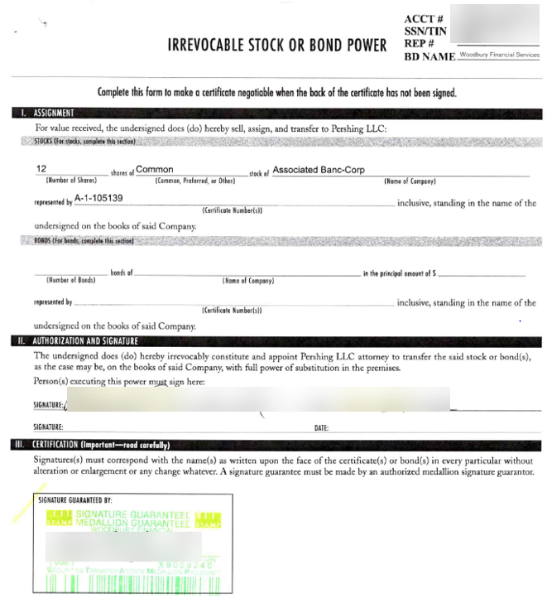
  - Write the account number on each certificate
  - Complete a Stock Power form for each certificate and have client(s) sign
  - Obtain a signature guarantee on each Stock Power form
  - Compile the paperwork so each Stock Power form is followed by the correct stock certificate
  - Mail the certificates via a trackable mail service directly to Pershing at:
Pershing LLC
300 Colonial Center Parkway, Suite 400
ATTN: Custody, 4th Floor
Lake Mary, FL 32746
- If the name(s) on the stock certificates are not identical to the name(s) on the brokerage account:
  - Write the account number on each certificate
  - Complete a Stock Power form for each certificate and have client(s) sign
  - Complete a Stock Certificate Third Party Release form or a “One and the Same” letter signed by all account owners if there are discrepancies between the name(s)
  - Some situations require a Letter of Authorization
    - Depositing individually owned shares into a joint account requires a Letter of Authorization signed by stock certificate owner indicating they are forfeiting 40% of the asset to the join account holder. The letter should specify the CUSIPs and Number of shares sent for deposit
    - Depositing joint owned shares into an individual account requires individual relinquishing ownership to sign a Letter of Authorization indicating CUSIPs and Number of shares they are giving up
    - Client with a new last name due to marriage/divorce depositing certificates to own account requires copy of marriage certificate or divorce papers or court document showing clients name has changed
    - There are other situations that may require a Letter of Authorization; please consult Advisor Group
  - Mail the certificates via a trackable mail service directly to Pershing at:
Pershing LLC
300 Colonial Center Parkway, Suite 400
ATTN: Custody, 4th Floor
Lake Mary, FL 32746
- Confirm the correct number of shares have been deposited in the correct account
- Follow up with Woodbury, if necessary

References

N/A

Revision History

Revision Date | Revised By | Revision Notes
11/14/2022 | Katie Weinschenk | Procedure Created

