Procedure Name: | Benchmark Update
Department: | Investment Team
Effective Date: | 11/14/2022 | Author: | Katie Weinschenk

Description

In order for the WMP QPR report to print correctly, we need to change a setting in the WMP household.

Assumptions

N/A

Procedure

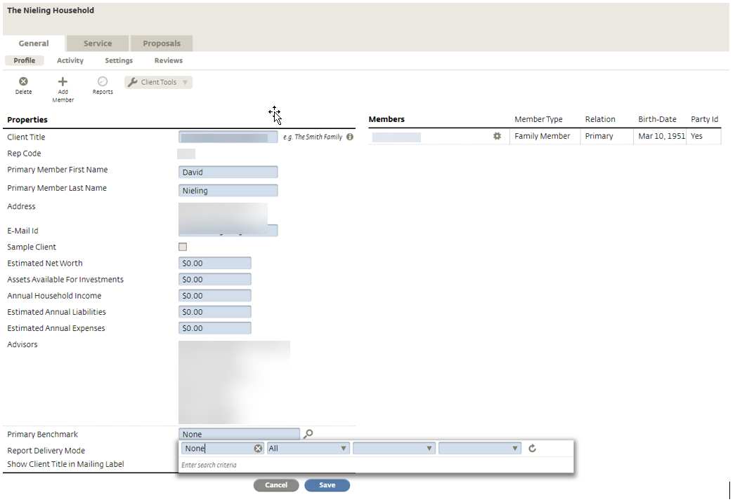

- Search for Client and pull up their household
- Click General Tab
- Click on Edit
- Go down to Primary Benchmark and click the magnifying glass
- Type in None and press enter
- Select None
- Click Save

References

N/A

Revision History

Revision Date | Revised By | Revision Notes
11/14/2022 | Katie Weinschenk | Procedure Created

