Procedure Name: | Death Claim
Department: | Investment Team
Effective Date: | 11/14/2022 | Author: | Katie Weinschenk

Description

When a client passes away, we assist the beneficiaries with making the death claim(s). Each fund company has its own paperwork and requirements to complete a claim, so we call to gather all of this information. It is vital that the beneficiaries bring in enough certified copies of the death certificate.

Assumptions

N/A

Procedure

- Change status in Redtail to Deceased and enter the Date of Death

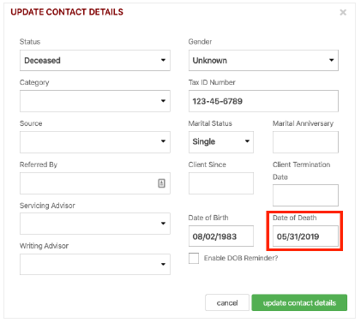

- Change spouse's marital status in Redtail, if applicable
- Change spouse to new Head of Household in Redtail, if applicable
- Adjust the Family Name in Redtail to reflect the new household arrangement, if applicable
- Check open activities on deceased client's contact record - move to new head of household's record, if applicable, or delete from the client file
- Acquire death certificate from the family
- Acquire all names, birthdates, Social Security Numbers, and contact information of all beneficiaries
- Forward death certificate to ServiceNet. Request client's status be changed to deceased and, if applicable, change spouse's status to widowed.
- Call all fund companies to inform them the client has passed away and obtain/complete all paperwork needed to complete death claim
- Prepare paperwork for each beneficiary
- Open beneficiary accounts in eQuipt
- Schedule appointment with spouse, executor, or beneficiaries to sign death claim paperwork
- Confirm all accounts have transferred to the proper beneficiaries
- Close the decedent’s accounts in Client Central

References

N/A

Revision History

Revision Date | Revised By | Revision Notes
11/14/2022 | Katie Weinschenk | Procedure Created

