Procedure Name: | Purchasing CDs in a Pershing Account
Department: | Investment Team
Effective Date: | 12/06/2022 | Author: | Katie Weinschenk

Description

CDs can be purchased in Pershing brokerage or advisory accounts.

Assumptions

N/A

Procedure

- In NetX, go to Menu – Trading – Fixed Income Center

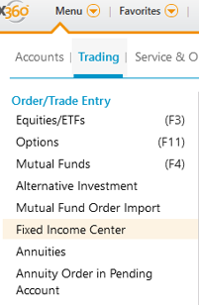

- The Fixed Income Center screen appears. Under New Issues, select Certificates of Deposit

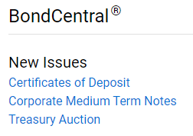

- The New Issue Center will pop up to allow you to search for available CDs
- In the search bar, the system automatically defaults to Principal

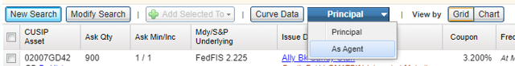

  - If you are buying the CD in a brokerage account, keep it defaulted to Principal
  - If you are buying the CD in an advisory account, select Agent

- Select Modify Search to drill down issuer, maturity dates, asset classes, et cetera

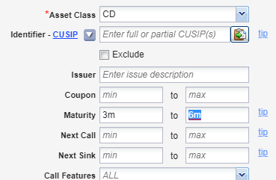

  - If you are looking for a certain maturity date, use m for months or y for year after the number
  - In this example, the assistant is looking for CDs with a maturity date 3-6 months out
  - When you have all your search criteria entered, click Search Offerings

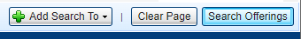

- A list of CDs that meets your search criteria will appear. Once you find the CD you wish to purchase for a client, select BUY on the right-hand side of the row

- The details of the CD will appear. After review, click Next Step

- For a CD purchase where we act as Principal (CD purchases within a brokerage account), enter the following order details:

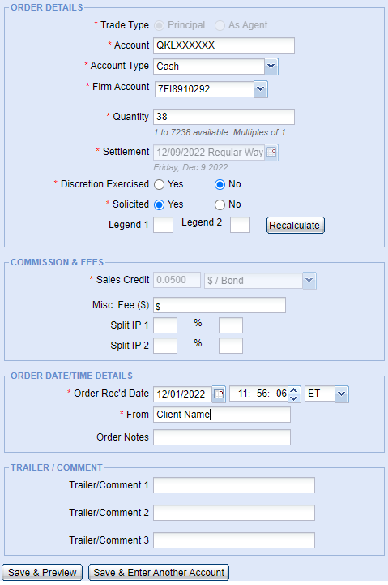

  - Account Number
  - Account Type – Defaults to Cash
  - Firm Account – Enter 7FI8910292 (7 Foxtrot India 8910292)
  - Quantity – round lots of 1000 (If you’re looking for a $50,000.00 CD, enter 50)
  - Discretion – no
  - Solicited – Yes
  - Sales Credit – A default will already be entered
  - Order Rec’d Date – Auto Time Stamps
  - From: Client Name
  - Save & Preview

- For a CD purchase where we act As Agent (CD purchases within an advisory account), enter the following order details:

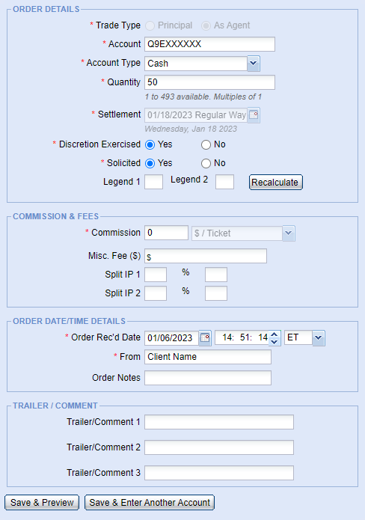

  - Account Number
  - Account Type – Defaults to Cash
  - Quantity – round lots of 1000 (If you’re looking for a $50,000.00 CD, enter 50)
  - Discretion – Yes
  - Solicited – Yes
  - Commission – 0 in advisory
  - Order Rec’d Date – Auto Time Stamps
  - From: Client Name
  - Save & Preview

- An order validated screen appears. Click OK

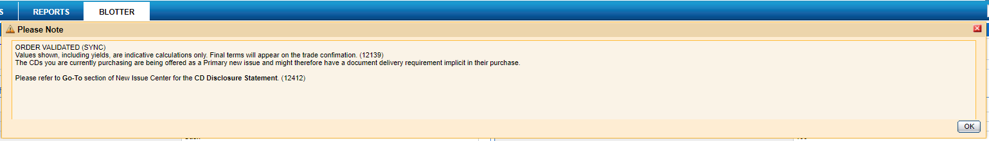

- Click Place Order
  - You will receive a confirmation that the request was received
  - Confirm the buy one of two ways:
    - In the Fixed Income Center, click on Certificates of Deposit then click on the Blotter tab

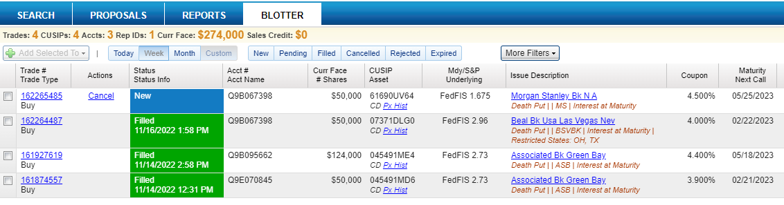

    - In the account’s Activity

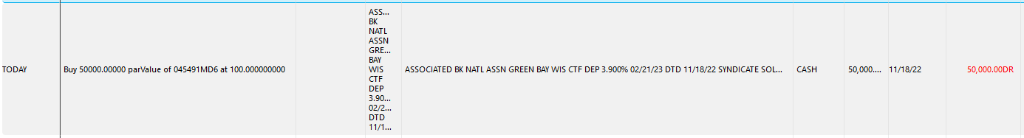

      - The buy will not show up in Activity until the request is filled, so there may be a delay in the CD appearing here

- Enter a note in the client’s Redtail detailing the transaction

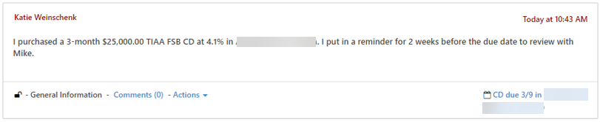

- Enter an activity in Redtail 2-weeks prior to the maturity date so rep can decide the next step with the client

- If you purchased the CDs in an advisory account, the CD will show up as a restricted security in WMP. However, you still need to add the Do Not Buy and Do Not Sell restrictions to the Controls Tab
  - From the Positions Tab, go to the Restricted Holdings and copy the Ticker for the CD

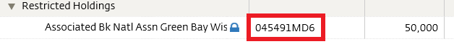

  - Go to the Control Tab and click Add Trade Control

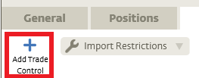

  - Click Add Security Restriction
  - In the Restriction box that appears, paste the Ticker for the CD under Security and click the box for Do Not Sell

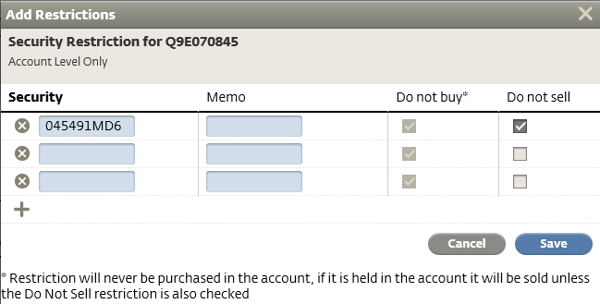

  - Click Save
  - The CD will now appear under Account Restrictions in the Control Tab

References

N/A

Revision History

Revision Date | Revised By | Revision Notes
12/06/2022 | Katie Weinschenk | Procedure Created

