Procedure Name: | ServiceNet
Department: | Investment Team
Effective Date: | 11/14/2022 | Author: | Katie Weinschenk

Description

ServiceNet is an online request and tracking system that provides the ability to submit service requests directly to the Home Office. Requests are submitted via ServiceNet and then assigned internally to the designated department.

Assumptions

N/A

Procedure

- You may access ServiceNet in the Launch Apps section of the Woodbury home page
  - If your advisor has elected to send ServiceNet notifications to you, please monitor your emails closely for ServiceNet notifications for actionable tickets.
- Creating a ServiceNet ticket
  - There are several ways to create ServiceNet tickets:
    - Search for the specific account in ServiceNet
    - Click on the account number
    - Scroll the bottom and click New ServiceNet Ticket

    - Select the appropriate template and ticket type. Click Continue
    - The advisor’s name and account number will auto populate if you’ve searched by account to start with
    - Add a description – start with LAST NAME, FIRST NAME – DESCRIPTION OF DOCUMENT
      - This will make it easier to search and find tickets later on
    - Upload a document by clicking Browse and find it on your computer
    - If you have further information to provide to the Home Office, enter it into the Notes section
    - Select Submit
  - In the ServiceNet module, click on Create New then click Ticket
    - Select both the ServiceNet template and ServiceNet ticket type. Click Continue
    - Select the appropriate rep, enter the account number, and add a description before attaching the document
    - Submit once all areas are complete.
- Responding to ServiceNet Tickets
  - The home office may reject or ask for additional information
  - Make sure to reply or add attachments directly into the ticket; do not create additional tickets
- Ticket Type
  - Service
    - Service Request: used to submit non-technical requests. This can include an inquiry about an account, a compliance-related issue, and operations-related questions. If your request is of a type for which a template exists, then it is recommended that you use the template. This is one of the most commonly used tickets for our office
    - WMP Service Request: used for general questions, issues, or requests that are in reference to a fee-based account. These requests are sent to the Investment Advisory team to resolve
    - Commission Inquiry: used to research the status of an anticipated commission payment
    - Technology Request: send requests related to any of the Advisor Group’s technology
    - Transition Service Request: used to send issues or requests to the transition team for new advisors to the BD. This request should only be used for new advisors who have been with the firm for 90 days or less. These requests are handled by the Home Office Transition Team
    - Annuity Link: allows you to link an annuity that is held at the annuity company to a brokerage account
    - WMP Manual Billing Adjustment: allows you to request an adjustment to fees that were charged to a WMP account
    - WMP Service Request: used for general questions, issues, or requests that are in reference to a fee-based account. These requests are sent to the Investment Advisory team to resolve
    - Fee Based Account Conversion: allows you to convert an existing commissionable Retail Brokerage account to an advisory account. Note that the account will continue to be held at Pershing. Both the brokerage and the advisory accounts must already exist in order to submit this type of request
    - Rates Management/Inquiry
    - IA Billing Termination
  - Licensing & Registration
    - Registration Maintenance
    - State Registration
    - Branch Address & Contact Info
    - Insurance Carrier Appointments
    - Exam Request
    - Personal & Contact Info
  - Marketing Reimbursement
    - Sponsorship – Entertainment
    - Sponsorship – Seminar
    - Sponsorship - General
  - Advertising Supervision
    - Correspondence: use to submit your monthly correspondence

- Mass Archiving
  - ServiceNet tickets that have the status of Closed Pending Confirmation may be mass archived.
  - Any attempts to archive tickets with any other statuses will result in an error message.
  - To Mass Archive Tickets
    - In ServiceNet, click on the dropdown menu and select Closed Pending Confirmation
    - This will bring up a list of all pending close tickets. Click the box on the upper left sections of the list. This will highlight all closed pending confirm tickets. Then click Archive Tickets

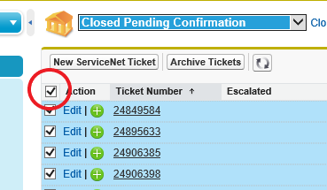

    - You will see this screen pop up asking you to confirm you wish to Close/Archive the tickets. Select the Close/Archive button to complete this task
- Set up Rep View in ServiceNet
  - Setting up Rep View will help you navigate the active tickets for one advisor in ServiceNet
  - Here’s how to set up the view:
    - Click Create New View in ServiceNet

    - On the screen that appears:

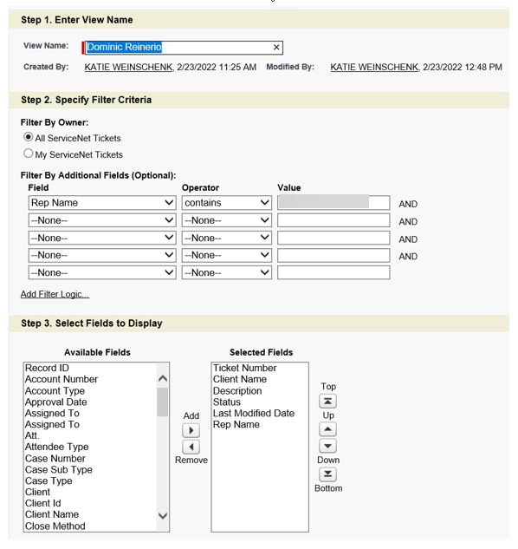

      - Type in the rep’s name as the View Name
      - In Step 2, select Rep Name – Contains – All rep codes for the rep
      - In Step 3, move the following fields to the Selected Fields box:
        - Ticket Number
        - Client Name
        - Description
        - Status
        - Last Modified Date
        - Rep Name.
    - Click Save
  - Once the Rep View is set up, select the rep name in the drop-down menu to view to view all applicable tickets
  - In order to see the tickets that need follow-up, you’ll want to sort the tickets by status in a reverse alphabetical order

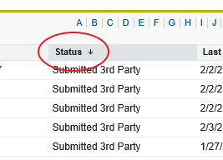

References

N/A

Revision History

Revision Date | Revised By | Revision Notes
11/14/2022 | Katie Weinschenk | Procedure Created

