Procedure Name: | Blottering Checks
Department: | Investment Team
Effective Date: | 11/14/2022 | Author: | Katie Weinschenk

Description

All checks received in our office for client accounts must be blottered.

Assumptions

N/A

Procedure

- For Pershing accounts –
  - Notate date received, amount of check, and account details in Redtail
  - Write the account number on the memo line of the check
  - Deposit the check in NetX360
  - Write down the date check was deposited, your initials, and the Mobile Deposit ID on a piece of paper
  - Scan the check and confirmation information into the Check Blotter file and client’s account file
  - Blotter check in V2020 by going to Client Management\Client Account Actions\Log A Check
    - Search for the client by last name
    - Select the correct account number

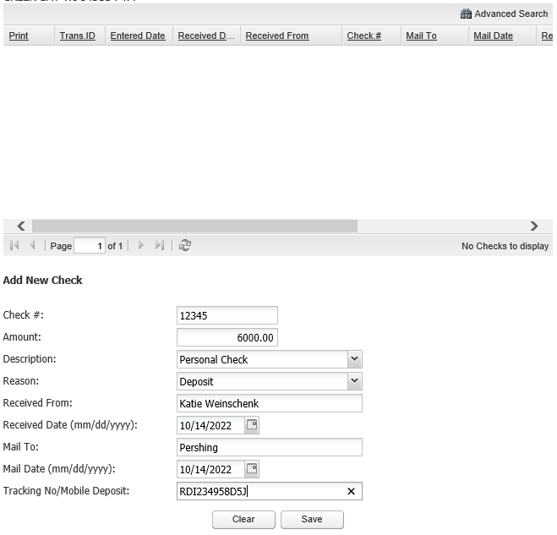

    - Enter the check number
    - Description: Select Personal Check, Bank/Cashier Check, or Other
      - Use Other when logging a Rollover Check
    - Reason: Almost always select Deposit
    - Received from: Client’s Name
    - Received Date: Date we took possession of the check
    - Mail to: Pershing
    - Mail Date: Must be within 24 business hours of taking possession of the check
    - Tracking Number: Enter the confirmation number you received when depositing the check into NetX360
    - Click Save
  - Update the NEW BUSINESS tracking sheet
  - Verify the contribution deposited into the client's account in NetX
  - Request the funds be invested in the model by entering a 03 - ADV INVEST ACCOUNT(S) IN MODEL activity
  - Confirm the funds invested in the model

- For Direct Mutual accounts –
  - Notate date received, amount of check, and account details in Redtail
  - Write the account number on the memo line of the check
  - Prepare the letter of instruction and FedEx form to send the check to the mutual fund company
  - Write down the date check was deposited, your initials, and the FedEx tracking number on a piece of paper
  - Scan the check, letter of instruction and confirmation information into the Check Blotter file and client’s account file
  - Blotter check in V2020 by going to Client Management\Client Account Actions\Log A Check
    - Search for the client by last name
    - Select the correct account number

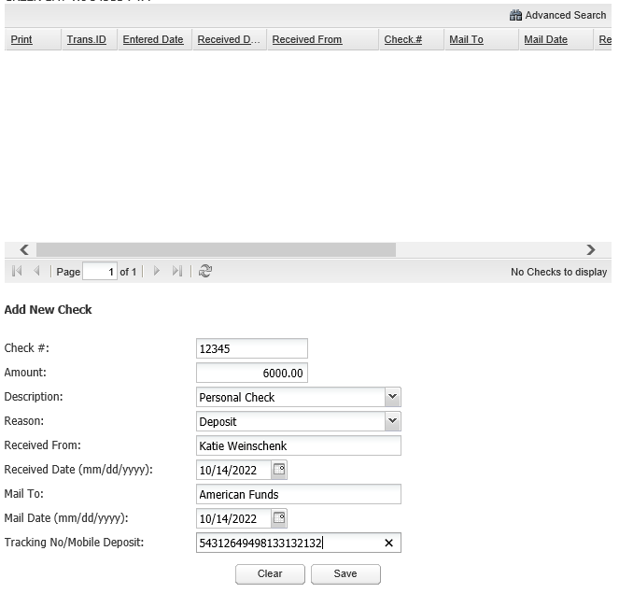

    - Enter the check number
    - Description: Select Personal Check, Bank/Cashier Check, or Other
      - Use Other when logging a Rollover Check
    - Reason: Almost always select Deposit
    - Received from: Client’s Name
    - Received Date: Date we took possession of the check
    - Mail to: Fund Company
    - Mail Date: Must be within 24 business hours of taking possession of the check
    - Tracking Number: Enter the FedEx Tracking Number
    - Click Save
  - Update the NEW BUSINESS tracking sheet
  - Verify the contribution deposited and invested in the client’s account

References

See NetX – Mobile Deposit for instructions on depositing Pershing checks.

Revision History

Revision Date | Revised By | Revision Notes
11/14/2022 | Katie Weinschenk | Procedure Created

