Procedure Name: | eQuipt for New Accounts
Department: | Investment Team
Effective Date: | 11/14/2022 | Author: | Katie Weinschenk

Description

eQuipt is a system to open new accounts through an electronic system which ensures all documents are in good order before sending the paperwork to the client to e-sign.

Assumptions

N/A

Procedure

eQuipt is a digital solution for opening accounts.
- Supported Client Types
  - Natural Person – must be a US citizen not living abroad; may not be a Government Official or Senior Foreign Official
  - Trusts – may not have a foreign party company or represent a private or foreign bank; authorized parties of the trust must be US citizens not living abroad, and may not be Government Officials or Senior Foreign Officials
- Supported Account Programs
  - Standard Brokerage
  - DirectChoice
  - Non-Brokerage
  - Advisor Managed Portfolios
  - Genesis Model Portfolios
  - Unified Managed Accounts
- Supported Account Registrations
  - Individual
  - Joint
  - UTMA
  - Sole Proprietor
  - Trust
  - Traditional IRA
  - Rollover IRA
  - Inherited IRA
  - Inherited IRA Trust
  - Roth IRA
  - Roth Inherited IRA
  - Roth Inherited IRA Trust
  - SIMPLE IRA
  - SEP IRA

- Accessing eQuipt
  - You will use a single sign-on through V2020 Advisor Portal. There are several places where you can click to access:

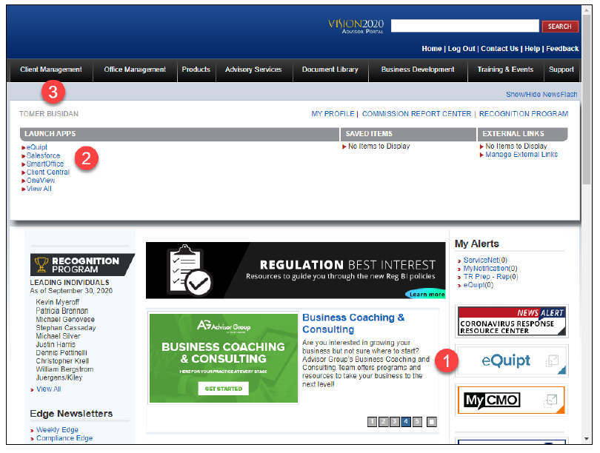

    - Click the eQuipt logo on the right side of the VISION2020 Advisor Portal home page (1)
    - Add eQuipt to your Launch Apps list (2)
    - Click the Client Management tab and select eQuipt from the Launch Apps list on the left (3)
- The Home Page
  - The first screen that displays after logging into eQuipt is the Investment Recommendations page. You can get back to this page at any time by clicking the Home link or the eQuipt for New Accounts logo in the top left

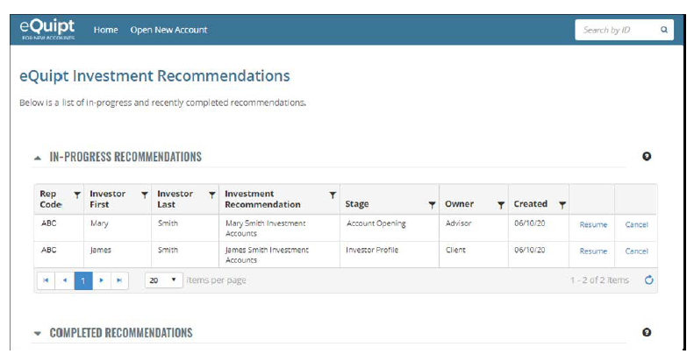

  - The Investment Recommendations page displays an In-Progress Recommendations table as well as a Completed Recommendations table. As you begin a recommendation and progress through the steps, it will display in the In-Progress Recommendations table. The Stage column displays the workflow step we are currently on. We can resume an in-progress recommendation by clicking its Resume link, or delete it by clicking its Cancel link
  - Once you’ve completed all steps and the paperwork has been signed and submitted, the recommendation will move down to the Completed Recommendations table
    - The Completed Recommendations table will provide a trailing 90-day view of all completed recommendations
- Starting a New Recommendation
  - To begin a new recommendation, click Open New Account along the top of the screen

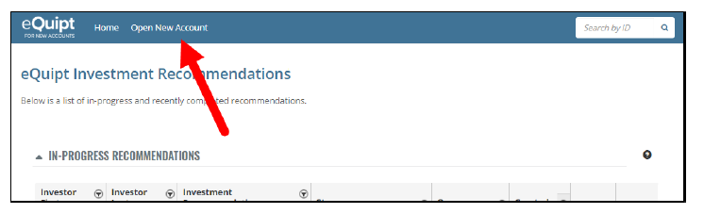

  - This will launch a small series of steps which display in the progress bar along the top of the screen

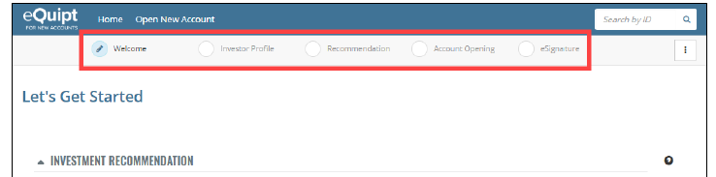

    - As you proceed through the steps, a checkmark will display next to those that have been completed, and a pencil will display next to the step you are currently on
    - The progress bar can also be used to return to a previous step in the workflow; just click on the step you wish to return to
    - Note: Each recommendation is assigned an ID number, which displays below the progress bar along the top of the screen (see arrow below). If you need to contact the home office about a particular recommendation, providing the ID number is the quickest way for the support staff to find it

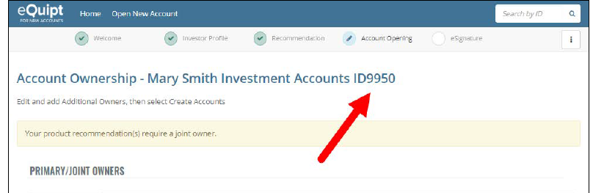

- Completing an Investment Recommendation
  - Welcome Step

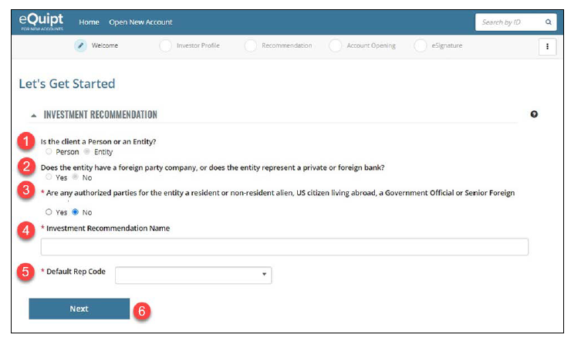

    - Select whether the client is a Person or an Entity (note: Trusts are the only entity type currently supported. If the trust has its own TIN, you’ll open it under entity. If the trust is under the client’s SSN, you’ll open it under a Person.) (1)
    - Entities Only: Indicate whether or not the entity has a foreign party company or represents a private or foreign bank. If the answer is yes, a message will display indicating you need to open the account in Client Central and you cannot proceed. (2)
    - Indicate whether or not the client is a resident alien, non-resident alien, Senior Foreign Official, US Citizen living abroad or a member of a private/foreign bank. If the answer is yes, a message will display indicating you need to open the account in Client Central and you will not be able to proceed. (3)
    - Input a name for the recommendation into the Investment Recommendation Name field. Generally, we just use the client’s full name here. (4)
    - Select the Default Rep Code. (5)
    - Click Next to continue to the Investor Profile Step. (6)
  - Investor Profile
    - In this step, you can enter a new client directly into eQuipt
    - You can also import your client from Client Central
      - You can search by First Name and/or Last Name. For entity clients, you can search by Entity name and/or TIN
      - When importing an active client, update any missing or outdated profile information in Client Central BEFORE importing them to eQuipt
      - When importing a prospect, you’ll be able to edit any of the profile fields. These updates will then update the record in Client Central
      - When creating a new client in eQuipt, this will automatically create the record in Client Central. For WMP users, it will create the WMP profile as well (even if you don’t open a WMP account)

    - Importing Clients/Prospects
      - If you import an active client, their profile will display as shown below. Note that the only editable fields are Email Address and Mobile Number. Both fields are required and must be provided if missing. If you imported a Prospect, all fields will be editable

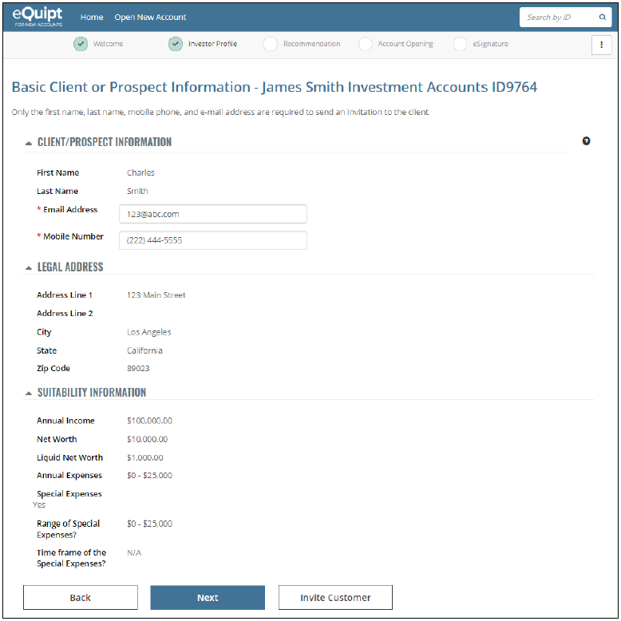

    - Importing Entities
      - If you import an active Entity client, their profile will display as shown below. Note the only editable fields are Email Address (which is optional) and Primary Phone (which is required). If you import a prospective Entity, all fields will be editable and any edits you input will update the profile in Client Central

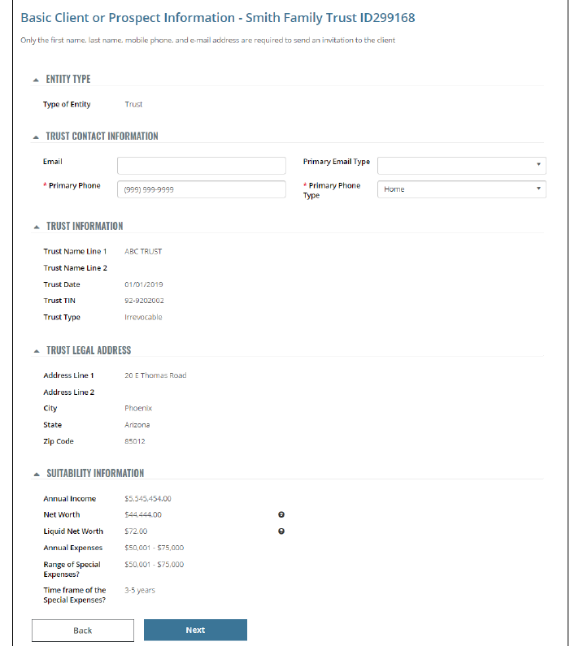

  - From this point, you would click Next or Invite Customer
    - Click Next if you would like to proceed to the recommendation step. There you will select investment goals for the client and complete a Risk Tolerance Questionnaire for each selected goal. Note that once you click next, the profile is pushed into Client Central and WMP
    - Click Invite Customer to send the client an invitation to the eQuipt Client Portal where they can complete the Legal Address and Suitability Information before inputting their own investment goals and completing the Risk Tolerance Questionnaire for each goal
    - The Client will receive an email from equipt@advisorgroup.com with the subject line “Let’s Start Opening Your Account” and will include co-branding with eQuipt and the Advisor Group firm.

    - The advisor will be copied on the email as well.

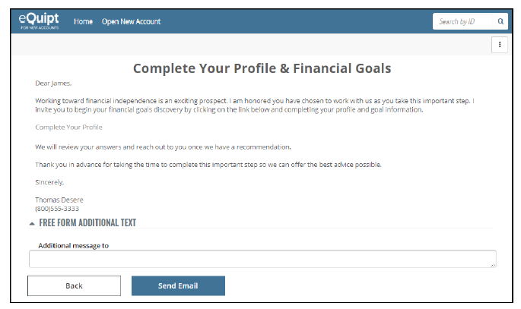

    - After clicking Send Email, you will be navigated back to the home page
      - The recommendation will display in the In-Progress Recommendations table. The Stage will display Investor Profile, and the Owner will display Client
      - The Owner is simply a reminder; it does not prevent the advisor from resuming the recommendation ourselves if the client contacts us directly with the requested information
    - When the client receives the invitation email and clicks the link, they will be brought to the eQuipt Client Portal to input their Responses
      - They will be asked to create a login if they are a new user or login with existing credentials if they are an existing user
      - After the client submits their responses, you will receive an email notification
      - On the eQuipt home page, the Stage will change to Investment Recommendation and the Owner will display Financial Professional. Click Resume to continue working on the application

- Investor Profile

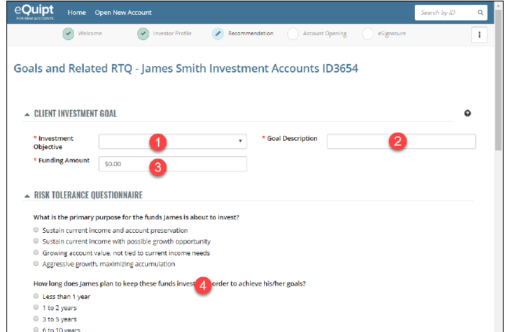

  - Select an Investment Objective from the drop-down menu (1)
    - General Investing
    - Education Savings
    - Retirement
    - Generate Income
  - Input a Goal Description (2)
    - So that it transfers to WMP correctly, I usually input “First Name Last Name – Type of Account (e.g., John Smith – Traditional IRA) however, if you’re opening more than one account under the goal, I’ll just use the Client First Name Last Name (e.g., John Smith)
  - Input the Funding Amount being allocated to this goal (3)
  - Next is the Risk Tolerance Questionnaire section, consisting of 6 questions. Provide the answers then click Next (4)
- The next screen (shown below) will appear:

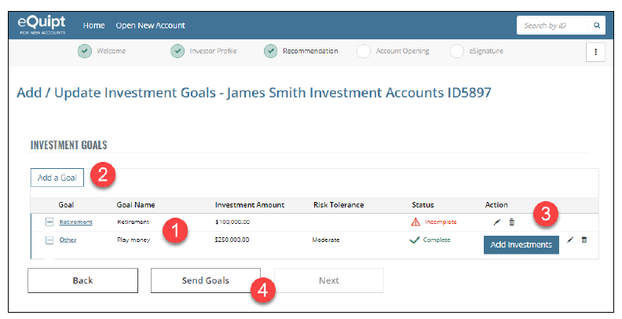

  - The goals you have inputted will display in the table. The Risk Tolerance and Status columns indicate whether the goal’s RTQ was completed. Note that in the above screenshot, the first goal’s status is Incomplete and the Risk Tolerance Column is blank, whereas the second goal is Complete and has a moderate risk tolerance (1)
  - You can add additional goals by clicking Add Goal and repeating above steps (2)
  - The Action Colum provides the ability to edit the goal or RTQ, delete the goal, or add investment recommendations to the goal (using the Add Investment button). The Add Investments button only displays once the Investor Profile and RTQ are complete. In the above screenshot, not that the goal with the completed RTQ has the Add Investments button while the incomplete goal does not. If the Investor Profile was incomplete, neither goal would have this option (3)
  - Send Goals is available for Person client types only, and is similar to the Invite Customer option previously discussed (4)
    - Either one can be used to request that the client complete an incomplete Investor Profile, as well as to have them input goals and RTQs
    - The only difference between them is that with Send Goals you have already inputted at least one goal for the client (and possibly answered some or all of the RTQ questions), whereas with Invite Customer, the client will input the goals themselves
    - If you clicked Send Goals, the process is very similar to the one previously shown for Invite Customer.
    - After clicking Send email, you will be navigated back to the home page. The recommendation will display in the In-Progress Recommendations table. The Stage will Display Investment Recommendation with the Client as Owner. The owner is simply a reminder and does not prevent us from resuming the recommendation ourselves
- Adding Investments
  - Once you or the client have completed the Investor Profile step, inputted goals, and completed the RTQs, you can add investments to each goal by clicking the Add Investments button. This will bring you to the Add Investments Screen

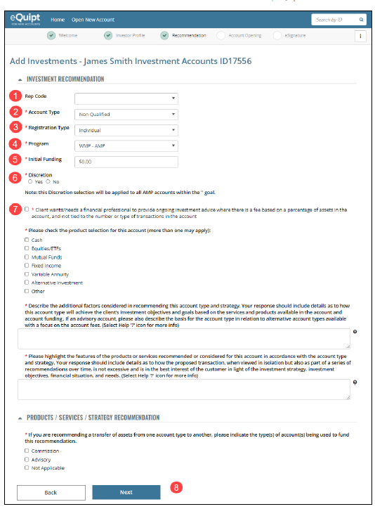

    - Rep Code: will default to rep code selected in the Welcome step (1)
    - Account Type: select Qualified or Non-Qualified (2)
    - Registration Type: select the desired account type (3)
    - Program Type: select the desired program (4)
      - If you select UMA, a Program Type menu will display where you select either UMA (for advisor-managed UMA models) or Strategist UMA (for strategist-managed UMA models
    - Initial Funding: will only display if AMP, WMP, or UMA are selected (5)
      - Input the amount being immediately invested in the account
      - For DCAs, put only the amount being immediately invested. Remember to call Advisor Group when the account number is established to put the remainder of the balance in Protected Cash so you can set up the DCA once the unprotected amount is received and invested.
    - Discretion: will only display if AMP is selected (6)
      - Always select Yes
    - The remaining questions on the screen are part of the Duty of Care (DOC) Addendum (7)
      - They do not display for entity clients.
      - For Person Clients, they only display for commission accounts and for fee-based accounts that are being opened under the Corporate RIA.
      - NOTE: the responses to the DOC questionnaire included in the Account Supervision record. An actual Duty of Care Addendum document is not generated and is not required
    - Click Next to continue (8)
  - Select the Model

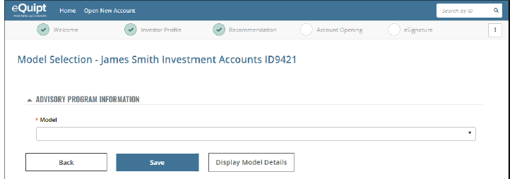

    - If you selected AMP, Model Portfolios, or UMA, then you will select the desired model from the drop-down menu
    - The model menu will display models matching the goal’s risk, with minimums that are equal to or below the Initial Funding amount that was inputted on the previous screen
    - After selecting a model, its minimum and description will display. To view the holdings and asset allocation, click the Display Model Details
    - Once you have selected the desired model, click Save to continue.
  - Rebalance Frequency (for UMAs only)
    - Select the frequency and click Next
  - Fee Schedule Rules (for AMP only)
    - Always select “In advance, linear, quarter ending balance – rep as PM – AMP Asset based allocation”

- Fee Schedule

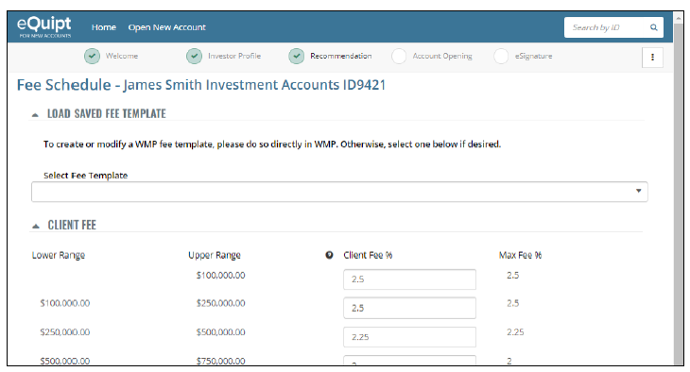

  - If you are using a fee Schedule you have previously saved as a template in WMP, you can select it from the drop-down menu
  - You can also enter frees manually
  - NOTE: For Model Portfolios and UMA, you are inputting the Advisor Fee whereas for AMP accounts, you will be inputting the Client Fee
  - Once you have inputted or selected the desired fee schedule, click Save to Continue
- Return to Recommendations Screen

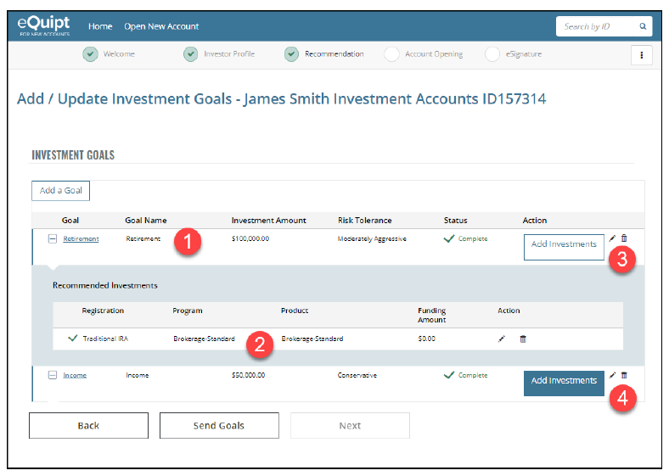

  - Client Goal with the account we added beneath it (2)
  - You can continue to add account recommendations to this same goal by again clicking the Add Investments button and repeating the previous steps (3)
  - If the recommendation consists of multiple goals, click the Add investments button next to the next goal and repeat the steps again (4)

- WMP Billing Groups

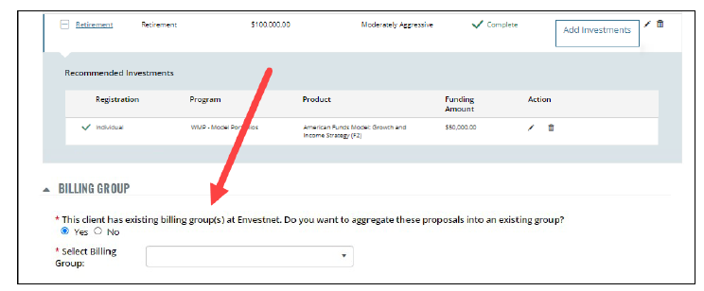

  - If the recommendation contains an AMP, Model Portfolio, or UMA account, and the client already has one or more existing billing groups in WMP, then a Billing Group section will appear on the screen. To add the new account(s) to the existing billing group, select Yes and then select the billing group from the Menu
  - If eQuipt does not find an existing billing group for the client, a message will display along the top of the screen indicating that a new billing group is being created for each Goal in the recommendation
    - If you are opening WMP accounts across multiple goals, this will result in multiple billing groups
    - To combine the accounts into a single billing group and/or to move the accounts to a billing group that may already exist under the spouse or other member of the client’s household, submit a ServiceNet ticket request to the home office
- Duty of Care Attestation
  - Once all goals have been added, RTQs completed, investments selected, and billing groups selected for WMP accounts being established:
    - For Entity clients, click Next to continue to the Account Opening step
    - For Person clients, you must first mark the checkbox to acknowledge the Duty of Care attestation
      - The attestation displays when opening a commission account or opening a fee-based account under the corporate RIA.
      - Note: It is acceptable for support staff to mark the checkbox on behalf of the financial profession, per the financial professional’s instruction.
    - After marking the attestation, you can now either click Next to continue to the Account Opening step or click Send Recommendation to send the proposal to the client for their review first
    - If you click Next to continue, you will not be making any further changes to the proposal
    - If you click Send Recommendation, you will send an email to the client for their review. Once reviewed, the client can approve and you will receive an email notification
    - At this point, the proposal is no longer editable
- Account Opening
  - If we created a new Person client, we will now be navigated to the Account Owner Page to complete the client’s profile. After doing so, we will then create profiles for all joint owners, if applicable
  - If we created a new Trust client, we will now complete profiles for all trustees before completing the trust’s profile as well
  - If we imported an active Person client, then we will be skipped over the Account Owner Page. If we are establishing joint accounts, then we will need to input join owners
  - If we imported an active Trust client, we will complete some required questions for the trust’s profile
  - Establishing the Accounts
    - After completing the profile for the person or trust, you will see a summary of accounts being established

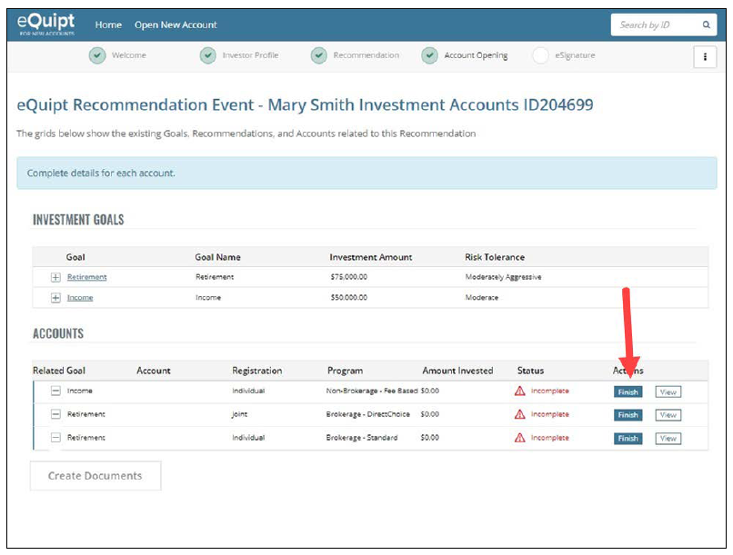

    - Click the Finish Button next to the account to continue to its Account Details page
    - If you are opening multiple accounts, you will repeat these steps for each account.

  - Here is an example of an Account Details page:

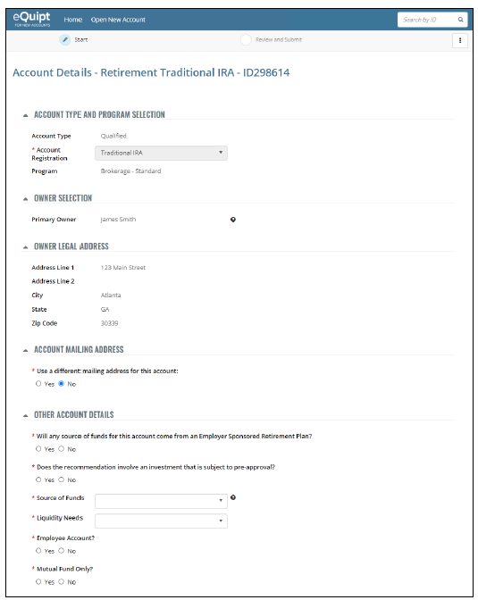

    - The page consists of various sections. Some sections apply to all account types and others vary depending on the type of account being established
    - Account Type and Program Selection
      - For most account types, you will not need to select anything here
      - For Joint accounts, here you will select the desired tenancy clause. The options will be filtered to only display those that are eligible in the client’s state of residence
      - For non-brokerage fee-based accounts, there will be additional questions asking if the account is a third-party money manager
    - Owner Selection
      - For most account types you will not do anything here
      - For joint accounts, you will select the joint owner(s) here
      - For Sole Proprietor accounts, you will be asked for a DBA Name, which will default to the client’s name but can be edited. You will also be asked if the account is being established under the client’s SSN or the DBA’s TIN
      - For Trust accounts for a Person client, you will input the name of the trust here
      - For accounts with an Entity Trust client, you can optionally input the For Benefit Of (FBO) information
    - Owner Legal Address
      - This section displays the client’s legal address and cannot be edited
    - Account Mailing Address
      - If the mailing address is different than the client’s legal address, you can input the mailing address here
    - Trustees: when opening a Trust account for a Person client, this section will show the Primary Trustee. You can input up to 3 additional trustees here
      - When opening an account for a Trust client, this section is not editable
    - Trust Information: when opening a Trust account for a Person client, you must select the Trust Type, input the Trust Date, and indicate whether the Trust Grantor is the same person as the Primary Trustee
      - When opening an account for a Trust client, the Trust Type, Trust Date, and TIN will not be editable
      - Trustee Certification of Investment Powers: when opening any account for an Entity Trust client or opening a Trust account for a Person client, you must answer a series of yes/no questions to indicate which activities the trust agreement permits. This will generate the TCIP form in the eSignature step
    - For the Benefit Of: this section applies to UTMA and 529 plan accounts only. You will provide the required information about the minor for whom the account is being established
    - UTMA Information: here you will sect the state in which the gift was given, whether it is an UTMA or UGMA (WI only allows for UTMAs), what the age of termination is (in WI it is 21), and what the custodian’s relationship is to the minor
    - SEP IRA Information: You will input the employer’s name and TIN
    - SIMPLE IRA Information: You will input the employer’s name, address, and TIN
    - Other Account Details: some questions here apply to all account types, and some depend on the account type selected
      - For all accounts:
        - Liquidity needs
        - If the investment requires pre-approval
        - Account source of funds
        - If this is an employee account (opening for financial profession or their family)
      - For all qualified accounts:
        - Whether any funds will come from an Employer Sponsored Retirement Plan. If yes, you will be asked to upload a completed Rollover Disclosure Form in the eSignature step
      - Indicate whether it is a Mutual Fund Only account (except for non-brokerage accounts)
    - Trusted Contact Info
    - Interested Parties
    - Transfer on Death Instructions can be added to brokerage Individual and JTWROS accounts
    - Beneficiaries
    - Decedents (for Inherited IRA and Inherited Roth IRA accounts)
  - Funding and Standing Instructions
    - Add:
      - Transfer instructions - Can process transfers into the account from up to 5 external accounts
      - Journal instructions - Must be like-to-like accounts within the firm (same owner and registration type)
      - Standing instructions linking the new account to the client’s bank account
    - Transfer from Another Firm

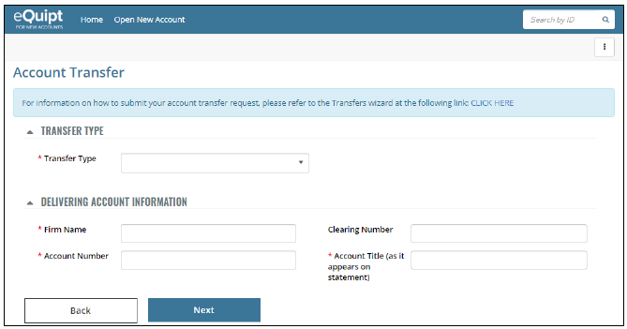

      - Transfer Type
        - Brokerage Account Transfer
        - DRS/DRIP
        - Direct Mutual Fund
        - Bank Retirement Plan Accounts
        - Other
      - Input the Delivering Account Number and Account Title as it appears on the client’s statement
      - For brokerage account transfers (ACATs) you can either manually input the delivering firm’s information (Firm Name, Contact Name, Address, City, State, Zip, Phone Number, and Clearing Number) or simply search for the firm by name and the fields will fill out for you. For all other transfer types, you will need to manually input the delivering firm information.
      - Depending on the Transfer Type selected, you may be asked whether the transfer is for all assets or for partial assets. If partial, an Asset List section is added to the screen where you will need to input the securities to be transferred (max of 28 lines)
      - For full DRS/DRIP transfers, indicate if fractional shares should be sold and the account closed, or transfer whole shares only
      - For Bank retirement account, indicate whether to liquidate the account immediately or at maturity

    - Bank Funding and Linking

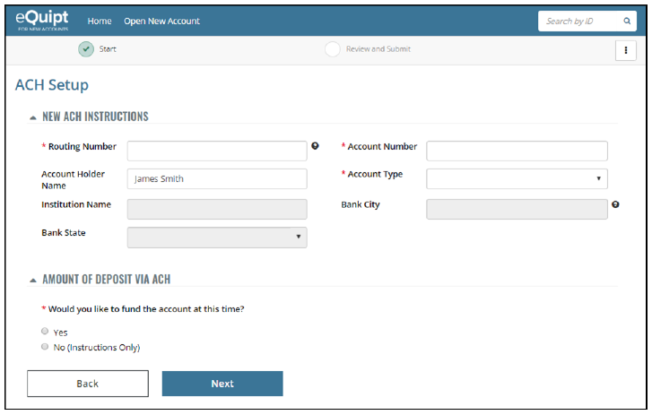

      - If you indicated that you are linking the client’s bank account, you will be presented with an ACH Setup screen
      - In the New ACH instructions section of the screen, input the bank information
        - Routing number
        - Account number
        - Account type
      - In the Amount of Deposit via ACH
        - Select No for standing instructions only
        - Select Yes if you are setting up standing instructions as well as processing an incoming ACH to fund the account. Input the amount to be transferred in a one-time deposit
      - For trust accounts, you will indicate whether the bank account is owned by the trust or the primary trustee
      - For UTMA accounts, you will indicate whether the bank account is owned by the custodian or minor with the custodian as an authorized party
      - For Sole Proprietor accounts, you will indicate whether the bank account is owned by the client or the DBA
      - If you are processing an incoming ACH into a qualified account, you will need to select a contribution type:
        - Prior year
        - Current year
        - Participant
        - Employer
        - Rollover
    - Journal from an Existing Account Within This Firm
      - If you indicated that the account will be funded via a FULL journal of assets from an account within the firm, then you will first be presented with a list of accounts that are eligible to be journaled from
      - Journals are only available form like-to-like accounts
      - After selecting the account, the Full Journal screen will display

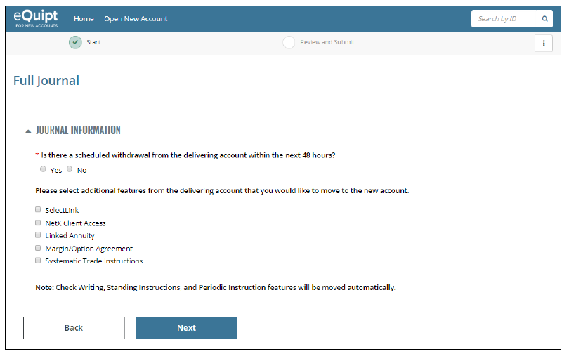

      - Indicate whether the delivering account has a withdrawal scheduled within the next 48 hours.
      - Select which additional optional features to copy from the delivering account
        - Check writing, standing instructions, and periodic instructions should move automatically
      - Click Next to continue
      - NOTE: in the eSignature step of the workflow, a Retail Brokerage Request Form will be generated (even if the account is a retirement account)
    - Funding Dashboard/Adding Additional Transfers
      - After you have inputted transfer instructions, standing instructions, or journal instructions, you will now be presented with a Funding Dashboard Screen

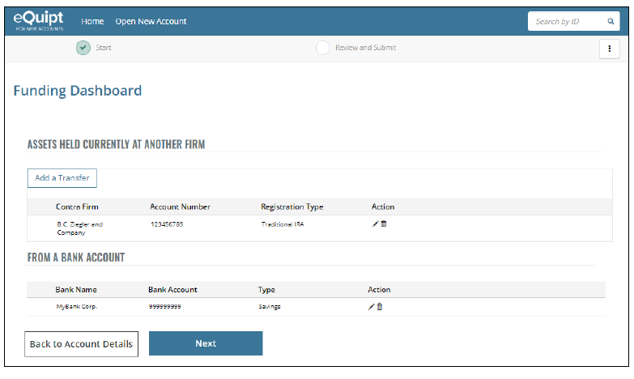

        - On this screen, you can edit or delete any inputted funding sources
        - To include additional transfers, click the Add a Transfer button and repeat the steps
        - Click Next when you have completed your entries
        - You will review your entries then Submit to generate the account number

    - You will now be returned to the Account Opening screen, an account number will have been issued, and the account’s status will be Complete

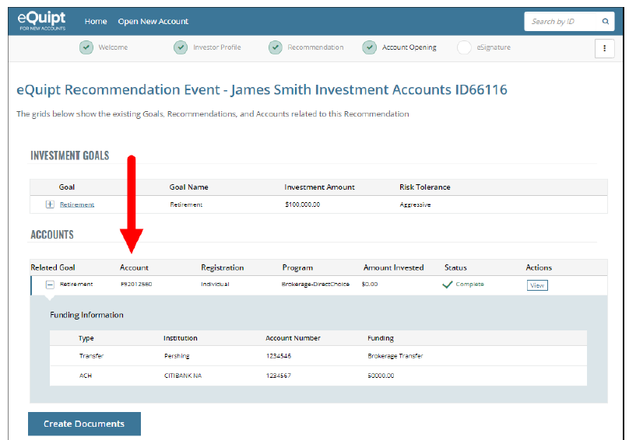

    - If you are establishing multiple accounts for the client, repeat the steps to establish each one
    - Once all accounts have been opened, the Create Documents button will become active
    - Click Create Documents to continue to the eSignature Step
- eSignature Step
  - eQuipt will automatically generate the documents needed to open the account(s)
  - Pending Receipt Section:

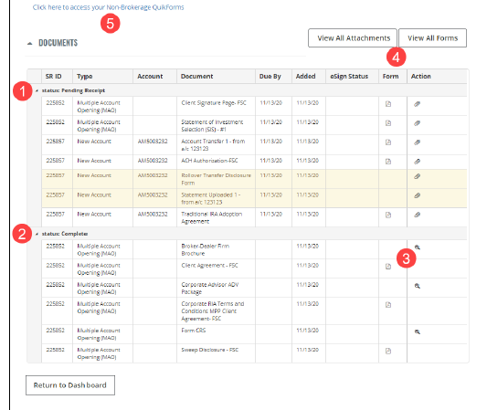

    - Documents are grouped into Pending Receipt List (1)
      - Documents that need to be signed by the client
      - If you are processing a transfer that is not Pershing to Pershing, then a yellow shaded row is added to the list labeled “Statement Uploaded”. Here you will click the paperclip and upload the statement
      - If you indicated that the account will be funded from an Employer Sponsored Retirement Plan, then a yellow shaded row is added to the list labeled “Rollover Transfer Disclosure Form”. Here you will click the paperclip and upload the form
      - If you are opening a SIMPLE IRA, then a yellow-shaded row is added to the list labeled 5304 IRS Form. Here you will click the paperclip to add a Form 5304

    - Documents are also grouped into a Completed List (2)
      - Documents that do not need to be signed such as agreements and disclosures
      - After you add an attachment to the Pending Receipt section, it moves to the Complete section. Once all documents are in the complete section, this completes the entire recommendation
      - If you use the eSignature feature, after the client has electronically signed, then all documents will move to the complete section
    - Some documents have a PDF icon in the Form Column and some have a magnifying glass in the Action column (3). You can use these to download or print an individual document. To view all documents as a Single PDF file, click View all Forms or View All Attachments (4)
    - A link to the Quik! eForms Library is available at the top of the page (5). This will bring you to Quik! where you can access any documents you may need
- Sending the eSign Invitation

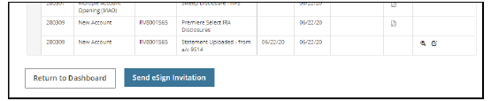

  - Once all required attachments are uploaded, the Send eSign Invitation button will be available
  - Once you click the button, you will be presented with a preview of the email that will be sent to the client
  - Click Send Email
- If the client physically signs the document, upload the documents back in to the eQuipt system by clicking the Documents tab in the client’s application

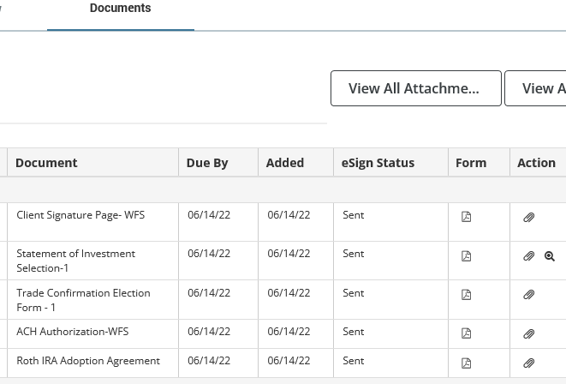

  - Click the paperclip icon next to the document
  - Attach the document and click Upload
  - Repeat the process until all signed documents have been uploaded into eQuipt
  - Once all documents are uploaded, the application will be automatically submitted to Woodbury and can be viewed and downloaded in ServiceNet

References

N/A

Revision History

Revision Date | Revised By | Revision Notes
11/14/2022 | Katie Weinschenk | Procedure Created

