Procedure Name: | Restrict Securities  (Advisor Model Portfolio)
Department: | Investment Team
Effective Date: | 11/14/2022 | Author: | Katie Weinschenk

Description

We restrict securities in AMP accounts to prevent them from being traded in an account.

Assumptions

N/A

Procedure

- From the Wealth Management Platform, search for the account in question
- From the Service tab, click on the hyperlinked account number
- Click on the Controls screen
- Click on the + Add Trade Control button in the upper-left corner
- On the menu, click on Add Security Restriction

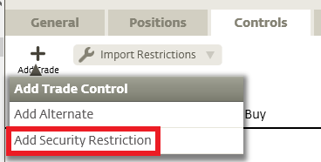

- In the Add Restriction Screen

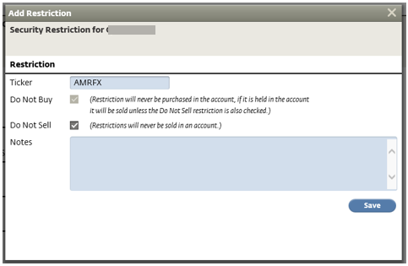

  - Type in the ticker symbol of the mutual fund or security you wish to restrict,
  - Click the Do Not Sell box, if applicable, and
  - Click Save
  - Check the box to Acknowledge the disclosure and click Continue. (You will only need to do this for the first restriction on the account.)
  - Repeat this step for each mutual fund or security you need to restrict

- The restriction will now appear under Account Restrictions on the Control Page

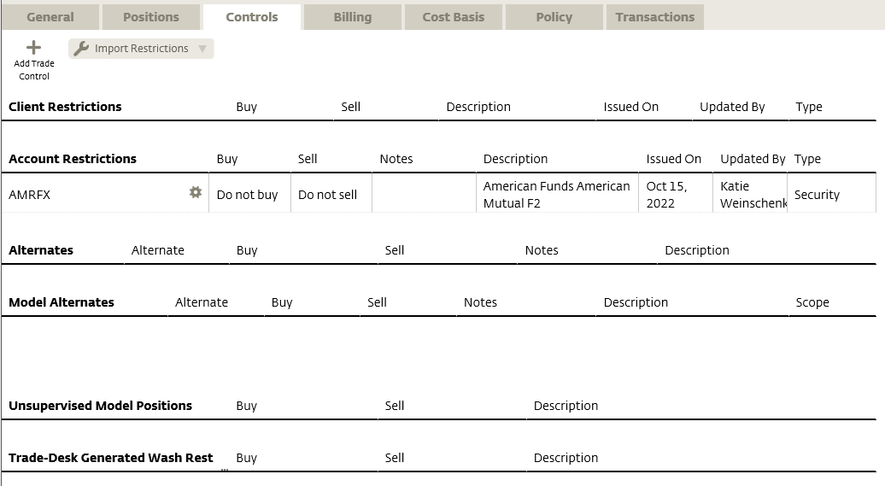

References

N/A

Revision History

Revision Date | Revised By | Revision Notes
11/14/2022 | Katie Weinschenk | Procedure Created

