|  |  |  |  |
| --- | --- | --- | --- |
| **Procedure Name:** | **American Endowment Foundation**  **Open a New Donor Advised Fund Account** |  | |
| **Department:** | Investment Team |
| **Effective Date:** | 11/14/2022 | **Author:** | Katie Weinschenk |

**Description**

When a client wishes to set up a Donor Advised Fund through American Endowment Foundation, we need to complete account set up at both American Endowment Foundation and Pershing using the following procedure.

**Assumptions**

N/A

**Procedure**

1. Go to <https://www.aefonline.org/>
2. In the upper right corner click For Advisors: Open a DAF Account and login
3. On the Home screen, click Start a New DAF Application in the upper-right corner. This will bring you to the Getting Started screen



1. Getting Started Tab

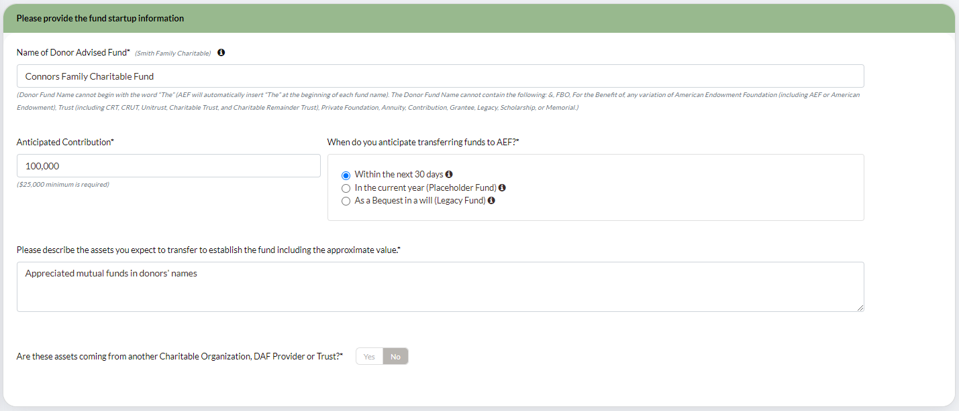

* 1. Name of Donor Advised Fund – Enter Last Name Family Charitable Fund
     1. If client requests a different name, please note the title cannot contain:
        1. &
        2. FBO
        3. For Benefit Of
        4. AEF
        5. American Endowment Foundation
        6. Charitable Trust
        7. Trust
        8. Private Foundation
  2. Contribution amount
     1. The contribution amount must be $25,000.00+
     2. The fund must maintain a $10,000.00 balance at all times
  3. When do you anticipate transferring funds to AEF? – Select the most appropriate time frame
  4. Please describe the assets you expect to transfer to establish the fund including the approximate value – enter the origin of the funds and expected value
  5. Are these assets coming from another Charitable Organization, DAF Provider, or Trust? – Select Yes or No
  6. Click Next to continue or Save to save and come back later

1. Donor Information Tab

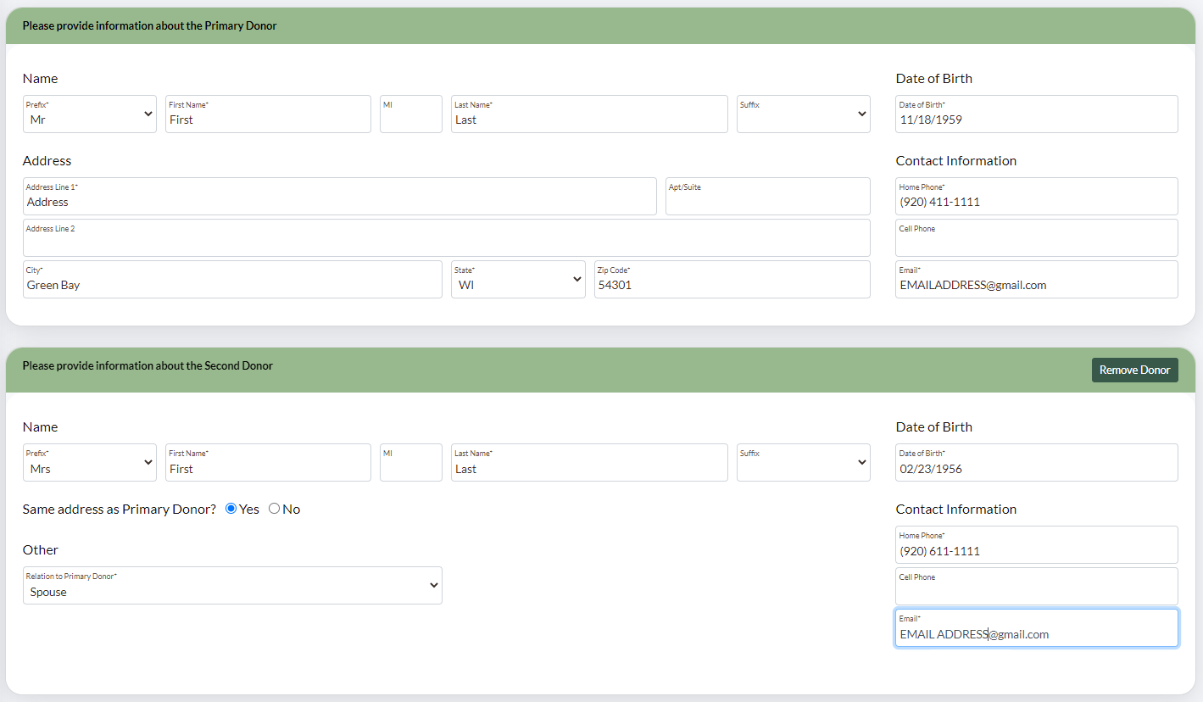

* 1. Enter the demographic information for the client wishing to set up the Donor Advised Fund
  2. To add additional donors, select Yes to Do you wish to add another donor?
  3. The donors cannot have the same address as the advisor, unless the advisor is setting up the fund for his/herself
  4. You cannot have more than three donors on one Donor Advised Fund
  5. The donors do not need to be related to one another

1. Disposition Tab
   1. This screen allows the donors to select what will happen at the time of their death

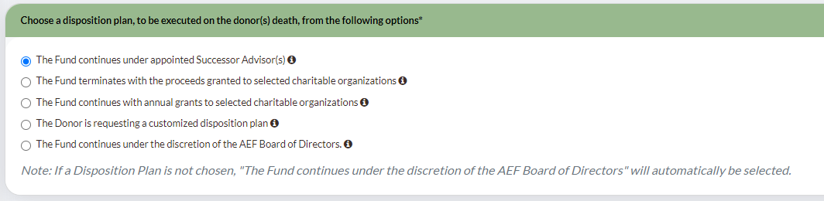

* 1. If the client wishes for Successor Advisors to take over the account, you will add them to the Disposition screen

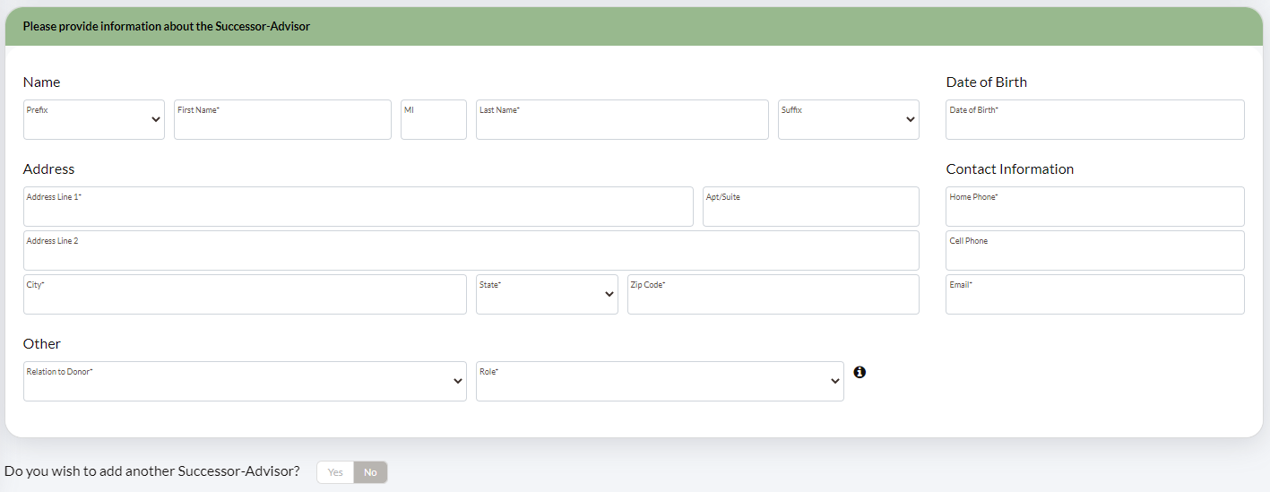

* + 1. You must enter the following information for each Successor Advisor:
       1. First Name
       2. Last Name
       3. Date of Birth
       4. Address
       5. Home Phone
       6. Email
       7. Relation to Donor
       8. Role
    2. The account can have up to 3 successor donors listed
    3. The successor donor can be a minor
    4. The successor donor must be a person; not an entity or trust

1. Investment Mgt Tab
   1. In this section, you will review the advisor information. You cannot edit this section. If there are any mistakes or updates, contact American Endowment Fund directly

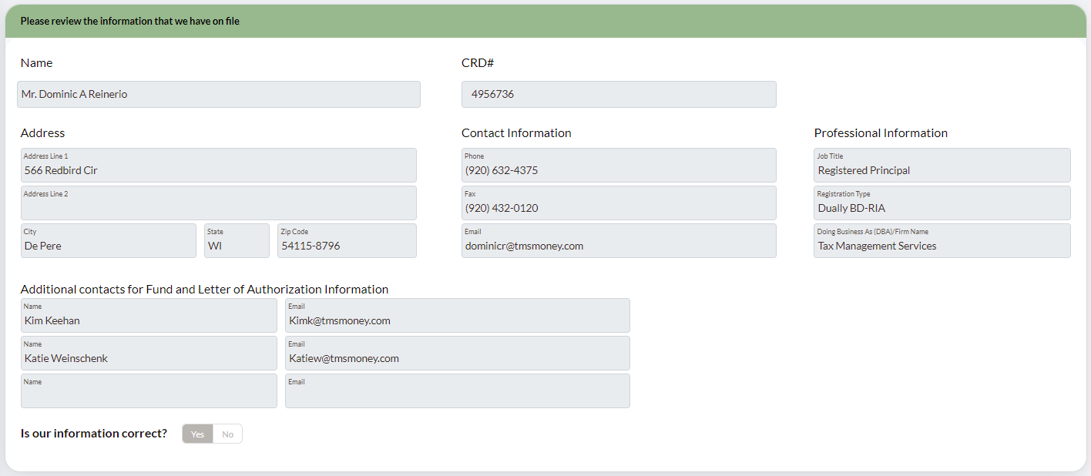

* 1. You will also answer the questions about the capacity in which the advisor is acting, whether they have discretionary or nondiscretionary authority, and which company will act as custodian

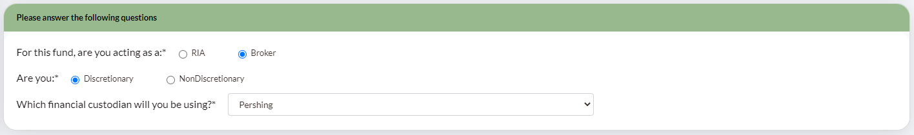

* 1. The final section of the Investment Mgt tab will ask who can access the DAF. The individual listed is the individual who created the DAF. They can be removed but additional individuals cannot be added. You’ll also find a record of the activity

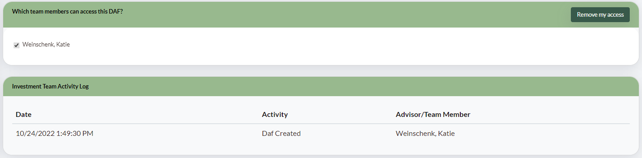

1. Once you’ve completed all four screens, you will proceed to the Signatures tab
   1. To begin the signature process, click Email the First Donor
   2. Once the first donor signs, the second donor will receive an email to sign the documents. This will repeat again if there is a third donor
2. Once all tabs are complete, you can click the button to send the application to the donor(s)
3. You will be notified when the application is signed. At this time, you’ll log back in to AEF, go into the application, and click Submit This Application
4. American Endowment Fund will provide you with all the documentation you will need to open the Entity Account for them
5. Once you receive the most recent copies of American Endowment Fund’s information, complete the following on Woodbury & Pershing’s end:
   1. Open American Endowment Fund as an entity under the representative’s ID number in Client Central, if needed
   2. Once AEF is an established entity under the rep, go to WMP and create the SIS for the account. When you get to the account opening section of the SIS, you will enter the information under the correct AEF. The account should be titled with the client’s last name and as many characters of the first name as possible
   3. When the account number is generated, complete the SIS and save a copy of the PDF for AEF’s signature
   4. Complete the following paperwork:
      1. Signature Forms for AEF and the Designated Signers
      2. ACH Authorization using the bank information provided by AEF
      3. Entity Beneficial Ownership form
      4. Trade Confirmation Election Form
   5. Upload all the paperwork requiring a signature into the AEF portal
6. American Endowment Fund will send back the signed paperwork as well as the Articles of Incorporation and Corporate Resolution. They’ll also send a Data Feed Addition form. Add the account number to this form
7. Submit the following documentation to Woodbury:
   1. Corporate Resolution
   2. Signature Forms
   3. ACH Authorization
   4. Entity Beneficial Ownership form
   5. SIS
   6. Trade Confirmation Election form
   7. Data Feed Addition form
8. Upload all documentation and signed paperwork to the client’s file

**References**

Use this section to link to any other documents referenced in the procedure

**Revision History**

|  |  |  |
| --- | --- | --- |
| **Revision Date** | **Revised By** | **Revision Notes** |
| 11/14/2022 | Katie Weinschenk | Procedure Created |
|  |  |  |