Procedure Name: | Adding Clients From Redtail  to Client Central
Department: | Investment Team
Effective Date: | 11/14/2022 | Author: | Katie Weinschenk

Description

In an attempt to cut down on double entry of client data, we are able to pull clients from Redtail into Client Central.

Assumptions

N/A

Procedure

- From Client Central, Click Add Client from Redtail link

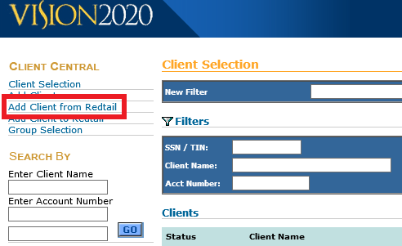

- A Search Box will appear. Type in the client’s last name and click Go
- Click the box next to the correct client’s name and click Submit

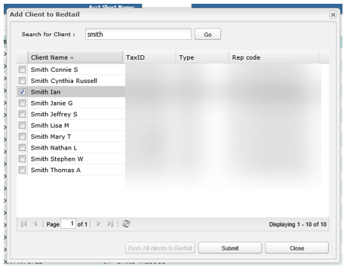

- The client will now appear in Client Central and you can add any missing information to the client

References

N/A

Revision History

Revision Date | Revised By | Revision Notes
11/14/2022 | Katie Weinschenk | Procedure Created

