Procedure Name: | Raise Cash  Advisor Model Portfolio
Department: | Investment Team
Effective Date: | 11/14/2022 | Author: | Katie Weinschenk

Description

When a client wishes to take a distribution from an AMP account, we may need to enter a Raise Cash request to ensure there is enough cash to cover the distribution.

Assumptions

N/A

Procedure

- From WMP, pull up the account where you will complete the Raise Cash request
- Click the Positions tab
- On the Positions screen, click on Generate Trades and select Raise Cash

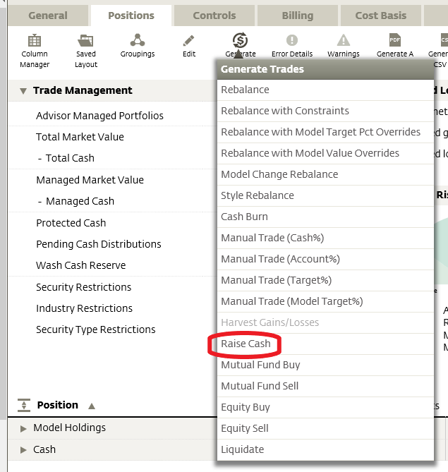

- On the following screen, enter:
  - Amount – requested amount of the distribution
  - Method – Fixed Amount
  - Rebalance Mode – Cash Rebalance – Minimize Trades

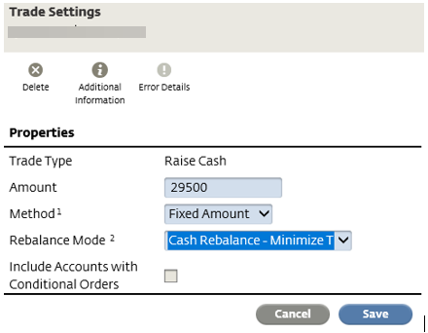

- Click Save
- Click Generate Trades

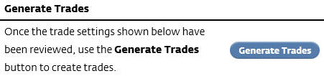

- Click Review Trades

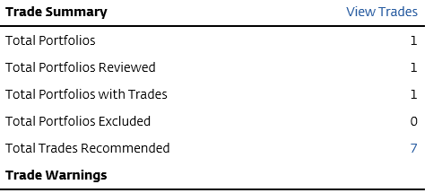

- Click the carrot next to Raise Cash to see all trades
  - If everything looks correct, go to Manage Trades and select Submit Trades

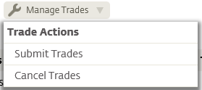

- The Execute Trades screen will appear, click Execute Trades

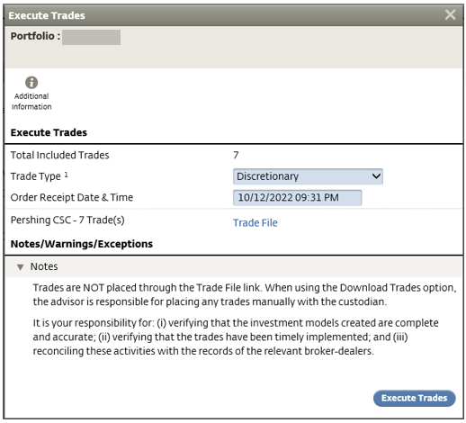

- Once trades are entered, ensure you have submitted the distribution request in NetX and/or sent distribution paperwork to Woodbury

REQUEST A WMP RAISE CASH
- Request a Raise Cash by entering a 03 – ADV Raise Cash Request activity into Redtail Complete paperwork and send to client for e-signature/schedule appointment for physical signature
- Verify asset movement is complete in NetX
- Request the funds be invested in the model by entering a 03 - ADV INVEST ACCOUNT(S) IN MODEL activity
- Verify funds are invested in receiving account model

References

N/A

Revision History

Revision Date | Revised By | Revision Notes
11/14/2022 | Katie Weinschenk | Procedure Created

