Procedure Name: | One-Time Buy
Department: | Investment Team
Effective Date: | 11/14/2022 | Author: | Katie Weinschenk

Description

When a client wishes to purchase an equity position in a Pershing account, an order needs to be placed in NetX using the following instructions.

Assumptions

N/A

Procedure

- From NetX, pull up the client’s account where the buy needs to take place
- If the client already holds the position in the account:
  - Click the Holdings tab

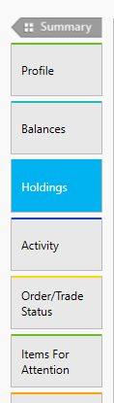

  - Find the holding you will click Buy More and click the action button next to it

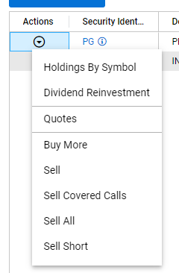

- This will bring up the trade execution screen

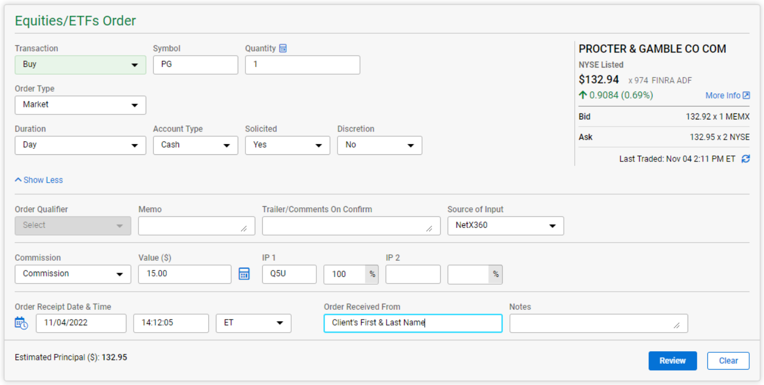

  - Transaction Type: populates from the choice you made on the last screen but can be adjusted in the drop-down menu, if needed
  - Symbol: auto populates
  - Quantity: Enter in the number of shares you wish to sell
  - Order Type: defaults to Market. Use the dropdown to change this as needed
  - Duration: defaults to Day. Use the dropdown to change this as needed
  - Account Type: defaults to cash. Use the dropdown to change this as needed
  - Select whether the order is Solicited or Non-Solicited
  - Order Qualifier: can leave blank unless needed
  - Memo: can leave blank unless needed
  - Trailer/Comments on Confirm: can leave blank unless needed
  - Source of Input: defaults to NetX360
  - Commissions: If advisor is charging commission, select Commission
  - Value: Enter the transaction charge (TMS uses a default of 15.00 for buys and sells)
  - IP 1: Enter rep code and 100%, unless the commission is split
  - Order Receipt Date & Time: Click the calendar & clock icon to autofill this section
  - Order Received From: Enter client’s name
  - Notes: can leave blank unless needed
- Click Review
  - If everything looks good, click Submit Order
  - If changes need to be made, click Edit Order

References

N/A

Revision History

Revision Date | Revised By | Revision Notes
11/14/2022 | Katie Weinschenk | Procedure Created

