Procedure Name: | View Systematic Order Instructions
Department: | Investment Team
Effective Date: | 11/14/2022 | Author: | Katie Weinschenk

Description

All systematic order instructions are available to view in NetX using the following instructions.

Assumptions

N/A

Procedure

- From NetX, go to the Profile tab
- Click on Periodic Instructions
- In the Periodic Instruction Type in the upper-right, select All Order Instructions

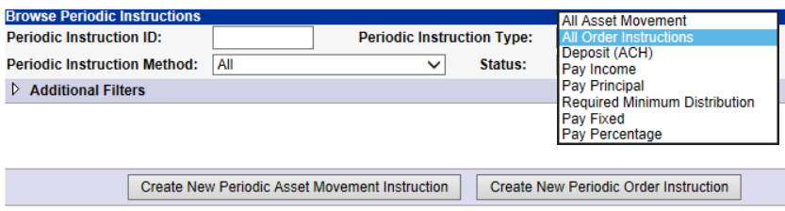

- Any open or cancelled systematic instruction will appear on the screen for your review

References

N/A

Revision History

Revision Date | Revised By | Revision Notes
11/14/2022 | Katie Weinschenk | Procedure Created

