Procedure Name: | Protect Cash in AMP Accounts
Department: | Investment Team
Effective Date: | 11/14/2022 | Author: | Katie Weinschenk

Description

For AMP accounts, cash can be protected for future distributions or if the client wishes to maintain a higher level of cash than the percentage allocated to the model.

Assumptions

N/A

Procedure

- From the client’s account in WMP, click on the Positions tab
- Click the Edit Button and select Edit Protected Cash

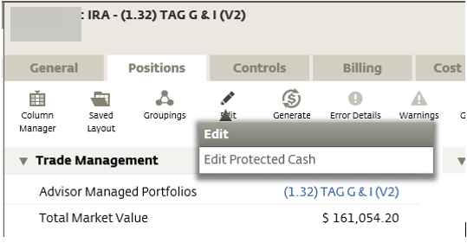

- The Update Protected Cash Screen will appear

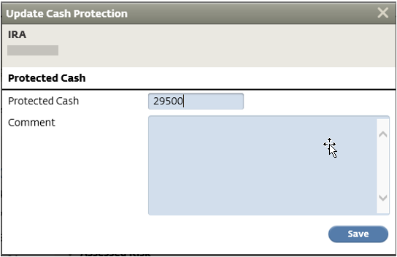

  - Enter the amount of cash you want to protect
  - Click Save
- The Protected Cash position will automatically update and be visible in Trade Management

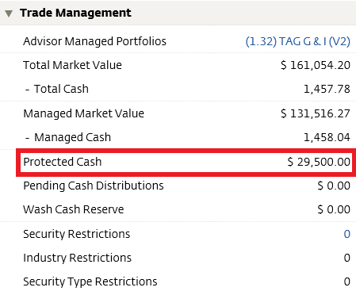

References

N/A

Revision History

Revision Date | Revised By | Revision Notes
11/14/2022 | Katie Weinschenk | Procedure Created

