Procedure Name: | Systematic Withdrawal  (Genesis Model Portfolio)
Department: | Investment Team
Effective Date: | 11/14/2022 | Author: | Katie Weinschenk

Description

Use the following procedure to set up a Genesis Model Portfolio account for systematic distributions.

Assumptions

N/A

Procedure

- For clients who have Genesis Model Portfolios who take recurring distributions, you must put instructions in both NetX and WMP
- Pull up the household in WMP and click on the Service tab
- You will see a list of each account that has been invested in WMP for the household
  - There are three lines for each account. Click on the second + icon for the account needing systematic instructions

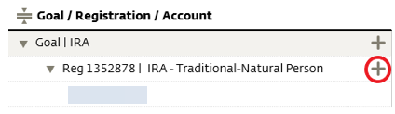

  - On the Create Service Request box, click Systematic Withdrawal – Set Up New

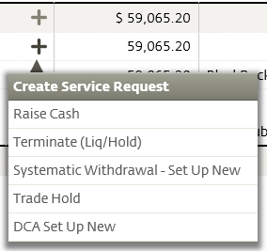

- A Set Up New screen will appear. Fill out the following sections:

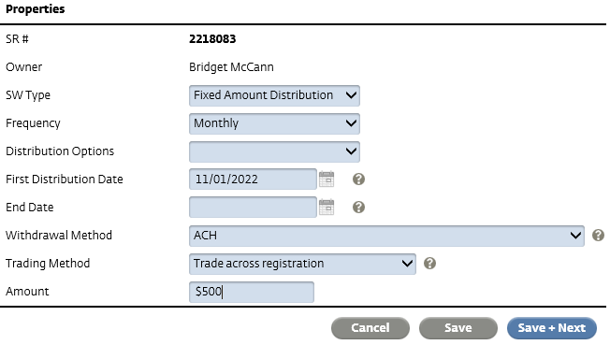

  - SW Type: Fixed Amount Distribution
  - Frequency: Select appropriate frequency
  - Distribution Options: Leave blank
  - First Distribution Date
    - NOTE: WMP needs a minimum of 15 days prior to the first distribution to set up systematic withdrawal instructions
    - If the first distribution is scheduled to go out sooner, you will need to do two things:
      - Complete a one-time Raise Cash for the first distribution
      - Set up the systematic withdrawal start date using the following distribution date
  - End Date: Leave Blank
  - Withdrawal Method: select appropriate method
  - Trading Method: Trade across registration
  - Amount: Enter the amount of the distribution
  - Click Save + Next
- On the next screen, click Submit Request

References

N/A

Revision History

Revision Date | Revised By | Revision Notes
11/14/2022 | Katie Weinschenk | Procedure Created

