Procedure Name: | Submitting Alternative Investment (AI) Paperwork – Pershing Accounts Only
Department: | Investment Team
Effective Date: | 11/14/2022 | Author: | Abbey Pilgrim

Description

The purpose of this procedure is to outline the process for purchasing non-tradable Alternative Investments (REIT, BDC, Hedge Fund, Managed Futures, Exchange Funds) through Pershing accounts.

Assumptions

Advisor will have already picked an approved product and completed the required training in order to advise on the AI product
All AI purchases need to be pre-approved by the home office
Accounts are established most times and have been invested into an AMP model. The AI will be purchased from Cash within the account.
Procedure

- Create the Client Record (if one does not already exist) through eQuipt or Client Central.
- Establish Brokerage or Advisory Account (if one does not already exist)
- Complete the form: Alternative Investment Pre-Approval Packet
- Complete the form: Private Investment Form (for Pershing Account only)
- Complete the Subscription Agreement for the approved sponsor. You can find most forms in eForms-Quik! or you can reach out to the regional director for the product company listed under the Products tab>Alternative Investments>Strategic Partners. Sometimes the forms are provided on their specific website.
- Submit all forms in a Service Net Ticket to the home office for Pre-Approval.
After Pre-Approval
- Once you get approval, submit the Private Investment Form and Subscription Agreement to Cashiering. If you are purchasing the AI outside of a Pershing Account (commissionable), you will then need to send the Subscription Agreement directly to the sponsor company. For Pershing accounts, Cashiering will start the purchase of the AI and send any documents directly to the sponsor company.
- Verify the AI purchase happens in the account. If advisory, make sure that new holding is restricted in WMP.

References

To find forms and an approved Products list for AI’s, in Vision2020, go to:

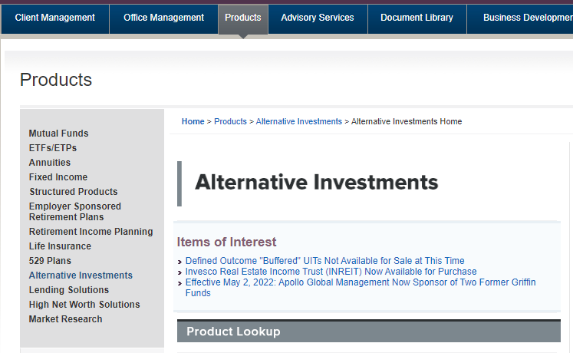

Revision History

Revision Date | Revised By | Revision Notes
11/14/2022 | Abbey Pilgrim | Procedure Created

