Procedure Name: | One-Time Sell
Department: | Investment Team
Effective Date: | 11/14/2022 | Author: | Katie Weinschenk

Description

When a client wishes to sell an equity position in a Pershing account, a sell order needs to be placed in NetX using the following instructions.

Assumptions

N/A

Procedure

- From NetX, pull up the client’s account where the sell needs to take place
- Click the Holdings tab

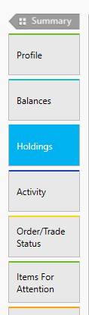

- Find the holding you will sell from and click the action button next to it

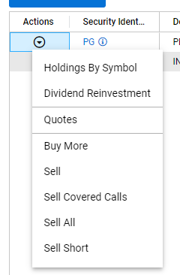

  - Click Sell to sell some but not all shares from the position
  - Click Sell All to sell all shares of the position

- This will bring up the trade execution screen

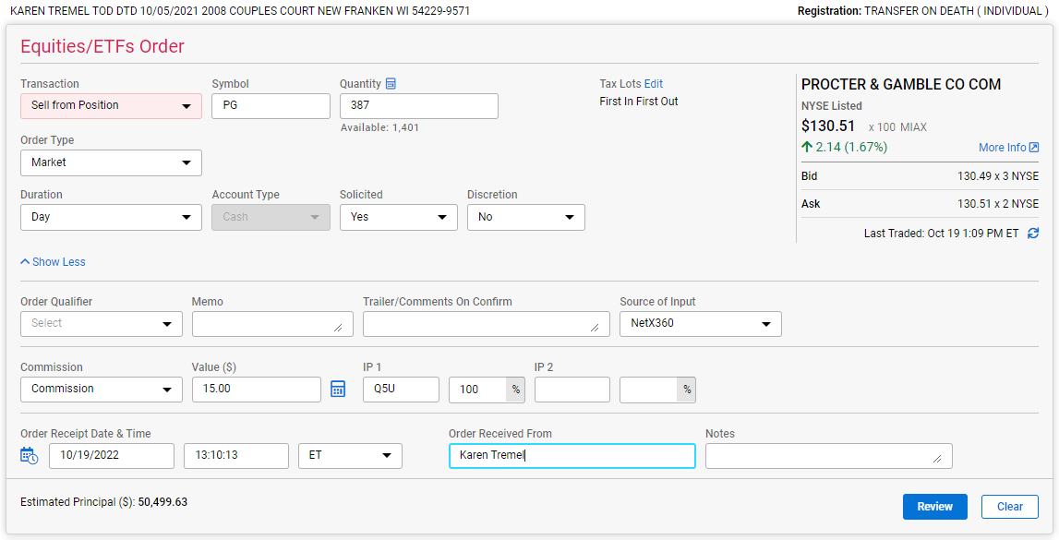

  - Transaction Type: populates from the choice you made on the last screen but can be adjusted in the drop-down menu, if needed
  - Symbol: auto populates
  - Quantity: Enter in the number of shares you wish to sell
    - If you need to calculate the number of shares, based on the dollar amount the client wishes to withdraw, you can click the calculator icon next to Quantity

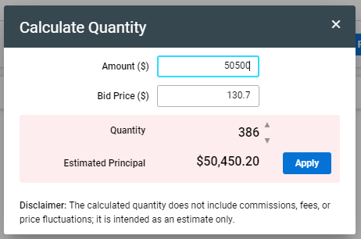

    - Enter and adjust the dollar amount to adjust the Estimated Principal. Once the Estimated Principal is over the dollar amount request, click Apply
    - This step is optional
  - Order Type: defaults to Market. Use the dropdown to change this as needed
  - Duration: defaults to Day. Use the dropdown to change this as needed
  - Select whether the order is Solicited or Non-Solicited
  - Order Qualifier: can leave blank unless needed
  - Memo: can leave blank unless needed
  - Trailer/Comments on Confirm: can leave blank unless needed
  - Source of Input: defaults to NetX360
  - Commissions: select Commission
  - Value: Enter amount indicated by rep
  - Order Receipt Date & Time: Click the calendar & clock icon to autofill this section
  - Order Received From: Enter client’s name
  - Notes: can leave blank unless needed
- Click Review

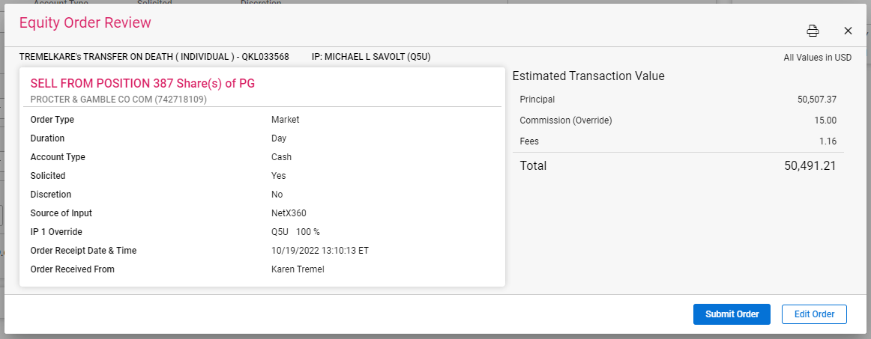

  - If everything looks good, click Submit Order
  - If changes need to be made, click Edit Order

References

N/A

Revision History

Revision Date | Revised By | Revision Notes
11/14/2022 | Katie Weinschenk | Procedure Created

