Procedure Name: | Standing Instructions
Department: | Investment Team
Effective Date: | 11/14/2022 | Author: | Katie Weinschenk

Description

Standing Instructions in NetX are used to add bank account information or tax withholding instructions to a Pershing account.

Assumptions

N/A

Procedure

- Once you are in the client’s account in NetX, click on the Profile tab
- Click on Standing Instructions

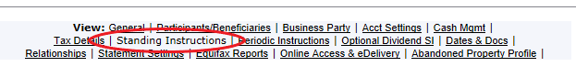
- Click Create New Standing Instruction. This will box where you will need to select the transaction type
  - To add bank account information, select ACH Standing Instruction

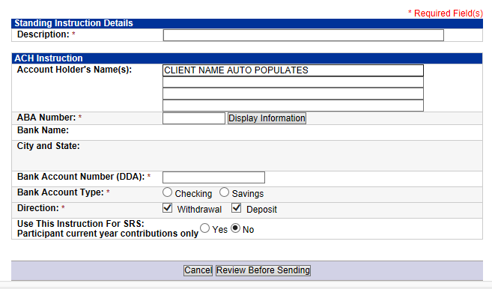

    - For the description, type in the bank name
    - The Account Holder’s Name will auto populate
    - ABA Number: Enter the bank routing number and click Display Information. Verify the bank name that pops up matches with the client provided information
    - Bank Account Number (DDA): Enter the client’s bank account number
    - Bank Account Type: Select Checking or Savings
    - Click Review Before Sending
    - A summary page will pull up. Confirm the information is accurate and submit the request in the system

  - To add tax withholding information on qualified accounts, select Tax Withholding (W4P) Standing Instructions

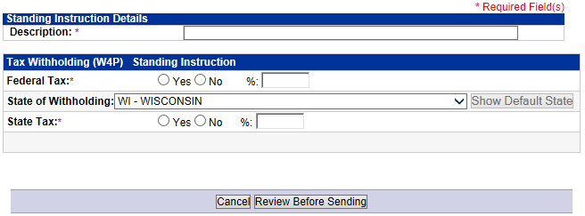

    - In the Description, enter Tax Withholding (% FED/% ST)
      - For example, if the client is withholding 25% federal and 15% the description would read Tax Withholding (25 FED/15 ST)
    - Click Yes next to Federal Tax. Enter the federal tax withholding percentage
      - Clients are required to withholding at least 10% federal
    - If the client wishes to withhold state tax, click Yes and enter the percentage
      - Some states require withholding; Wisconsin does not
    - Once the information is filled in, click Review Before Sending
    - If everything looks correct, submit the instructions

References

N/A

Revision History

Revision Date | Revised By | Revision Notes
11/14/2022 | Katie Weinschenk | Procedure Created

