Procedure Name: | Systematic Distribution  (Qualified Account)
Department: | Investment Team
Effective Date: | 11/14/2022 | Author: | Katie Weinschenk

Description

A systematic distribution is money sent from an investment account to a bank account or via check automatically at regular intervals. We use the following steps to enter the instructions in a Pershing account.

Assumptions

N/A

Procedure

- Complete an IRA-ESA Distribution Request for client e-signature or physical signature
- If the client does not have a bank account on file, complete an ACH Authorization for client e-signature or physical signature
- Go to the correct account in NetX
- Click on the Profile tab and click on Periodic Instructions

- Click the Create New Periodic Asset Movement Instruction button

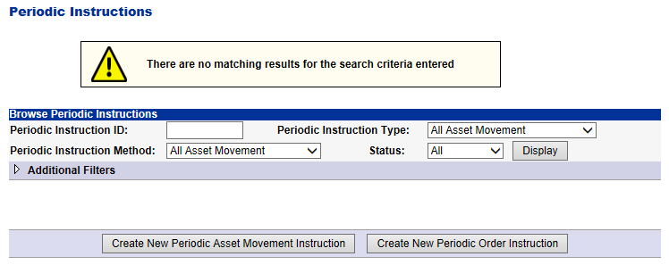

  - Confirm the account number is correct and click Continue
- On the following screen, set up the systematic distribution instructions

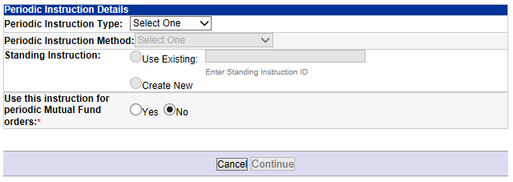
  - Periodic Instructions
    - Deposit (ACH) – do not use for distributions
    - Pay Income – use this to set up dividend sweeps from the account
    - Pay Principal – use this to set up systematic distributions from the account
  - Periodic Instruction Method
    - Fed Fund – do not use for systematic distributions
    - Journal Between Accounts – do not use for systematic distributions
    - 3rd Party Check – do not use for systematic distributions
    - ACH – use this option to sent money to bank account
    - 1st Party Check – use this option to send money via physical check to address of record
  - Standing Instruction
    - If you use ACH as your Periodic Instruction Method and an bank account is already on file, click the Use Existing button and select the account from the dropdown menu
    - If you are adding a new bank account, select Create New
  - Use this instruction for periodic Mutual Fund Orders – defaults to No. Keep this as No.
  - Click Continue
- If you need to add bank account information and distribution instructions, you will complete the following
  - Pay Principal Details

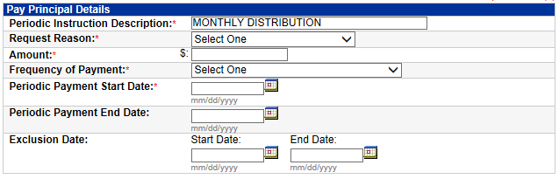

    - Periodic Instruction Distribution: Enter Monthly Distribution as the title
    - Request Reason: select appropriate reason (most often, it’s Normal)
    - Amount: enter the distribution amount
    - Frequency: select the appropriate frequency
    - Periodic Payment Start Date: select the first date the distribution should be sent to the client
    - Periodic Payment End Date: can be left blank unless you have a specific date to stop payments
    - Exclusion Date: can be left blank unless there is a certain period of time the client does not wish to receive distributions
  - Amount & Tax Withholding Information

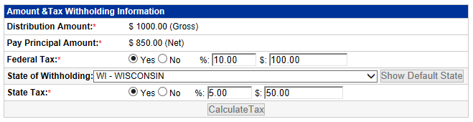

    - Distribution Amount: enter the gross distribution amount
    - Pay Principal Amount: will auto calculate the net payment after adding tax instructions
    - Federal Tax: if the client would like to withhold Federal Tax, click the Yes button and enter in the percentage of tax withholding
    - State of Withholding: will populate the default state for the client
    - State Tax: if the client would like to withhold State Tax, click the Yes button and enter in the percentage of tax withholding
    - Once you have entered in tax withholding information, click Calculate Tax

  - ACH Instruction

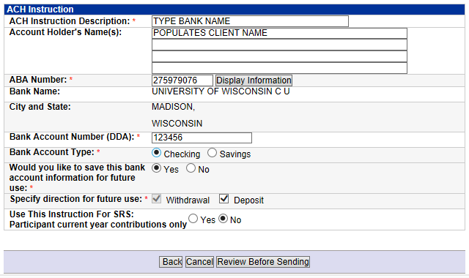

    - ACH Instruction Description: Enter the bank name
    - Account Holder’s Name: client name will populate automatically
    - ABA Number: Enter the routing number and click Display Information
    - Bank Account Number (DDA): Enter the bank account Number
    - Bank Account Type: Select Checking or Savings
    - The remainder of the information prepopulates and can be left as is
- Once all information is entered, click Review Before Sending
  - If all information is correct, click Send Periodic Instruction Request
  - If you need to correct any information, click « Back to Transaction
- The Systematic Distribution will appear under Periodic Instructions

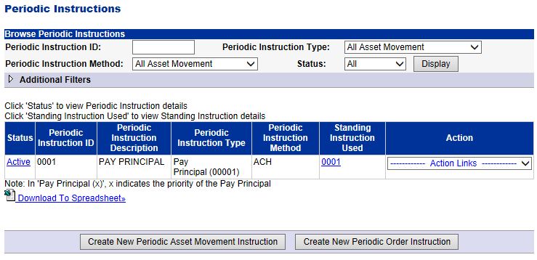

- Remember to set up systematic sells in NetX for brokerage accounts, protect cash equivalent to three months of distributions in WMP for AMP accounts, or set up a systematic Raise Cash instructions in WMP for Genesis Model Portfolio
- Create a reminder in Redtail to confirm the first distribution has occurred

References

Use this section to link to any other documents referenced in the procedure

Revision History

Revision Date | Revised By | Revision Notes
11/14/2022 | Katie Weinschenk | Procedure Created

