Procedure Name: | Qualified Charitable Distributions (QCD) – Pershing Accounts Only | 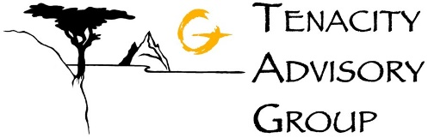
Department: | Investment Team
Effective Date: | 11/14/2022 | Author: | Abbey Pilgrim

Description

Follow these steps if a client wants to request a Qualified Charitable Distribution to a charity, including for their RMD.

Assumptions

There is a Pershing account established, whether it is Advisory or non-Advisory.

Procedure

- For a distribution from an IRA:
  - Use form IRA/ESA Distribution Request which can be found in eForms-Quik!
  - Fill out applicable sections
  - In Step 5. Method of Delivery: Select Third Party Check Request
- For a distribution from a non-qualified account:
  - Use the Third-Party Distribution Request form

References

N/A

Revision History

Revision Date | Revised By | Revision Notes
11/14/2022 | Abbey Pilgrim | Procedure Created

