Procedure Name: | Submitting Variable Annuity (VA) Business
Department: | Investment Team
Effective Date: | 11/14/2022 | Author: | Abbey Pilgrim

Description

Follow these steps if purchasing a Variable Annuity policy.

Assumptions

Advisor will have already picked an approved product and completed the required training for the VA purchase.

All VA purchases (Initial or Replacement) need to be pre-approved by the home office (see Chart below)

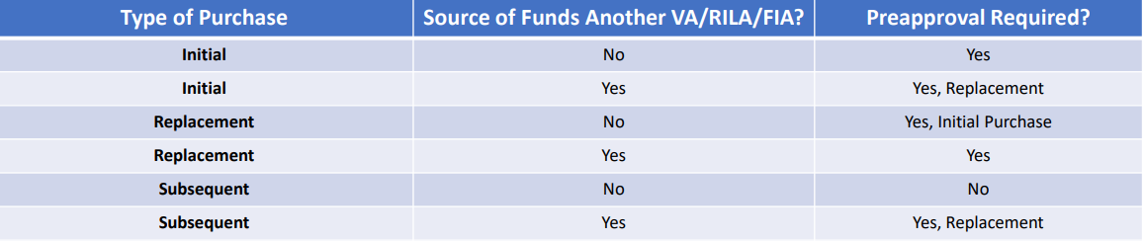

Procedure

- Create the Client Record (if one does not already exist) through eQuipt or Client Central.
- Establish Non-Brokerage Account through eQuipt or Client Central. Will need to NBW# for the form.
- Complete Carrier Paperwork: Advisor will get the application from their contact at the Carrier or you will need to reach out to the contact and get the correct application paperwork. Include their Transfer form if you are funding the VA from another investment account.
- Complete Annuity Pre-Approval Packet: this can be found in eForms-Quik!
  - Need to complete the Annuity Intelligence (comparison). Found in Vision2020.
- Submit Carrier Application and Annuity Pre-Approval Packet to Sales Supervision by creating a ServiceNet ticket and submit ALL forms for Approval. If you are doing a 1035 exchange, include a current Statement of the VA.
After Pre-Approval
- You will receive the Pre-Approval notice in the ServiceNet ticket. If not approved, fix errors and wait for approval.
- Once approved, send the Annuity Application and Transfer Form (if applicable) to the Carrier via e-mail, fax, or mail.
- Watch for the funding to take place over the next few weeks.

References

To find forms and an approved Products list for VA’s, in Vision2020, go to:

Revision History

Revision Date | Revised By | Revision Notes
11/14/2022 | Abbey Pilgrim | Procedure Created

