Procedure Name: | AMP Model Change
Department: | Investment Team
Effective Date: | 11/14/2022 | Author: | Katie Weinschenk

Description

To change the model in an AMP account, use the following instructions.

Assumptions

N/A

Procedure

- In WMP, pull up the account needing a model change. Prior to changing the model, confirm any security restrictions that may need to be placed in the account with the financial advisor
- From the General tab, click on Account Tools and click Attach Model

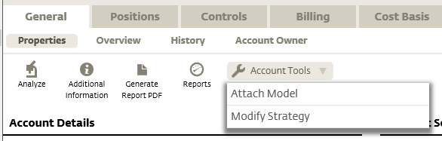

- The Attach Model screen will appear. Use the dropdown menu next to New Model to select the appropriate model and select Save

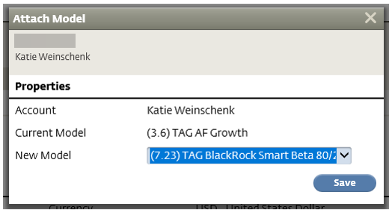

- A confirmation screen will pop up. It will ask you to confirm the model change if you are in the same risk classification or alert you if you are attaching a model with a new risk classification. Review and click Continue

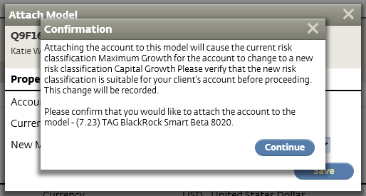

- Click on the Positions tab
- Click on Generate Trades and select Rebalance

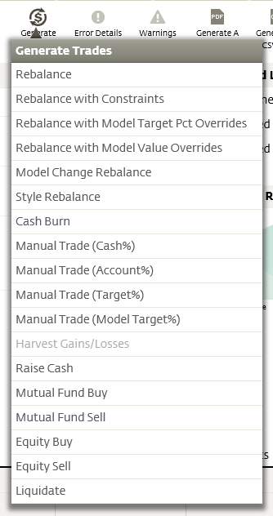

- Click the Generate Trades button

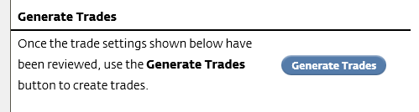

- This will take you to the Trade Settings – Soft Rebalance screen. Click Review Trades, expand the trades, and confirm the buys and sells
- If everything looks good, click Manage Trades and Submit Trades

References

N/A

Revision History

Revision Date | Revised By | Revision Notes
11/14/2022 | Katie Weinschenk | Procedure Created

