Procedure Name: | Goal Modification  (Genesis Model Portfolio)
Department: | Investment Team
Effective Date: | 11/14/2022 | Author: | Katie Weinschenk

Description

To change the model in a Genesis Model Portfolio account, use the following instructions.

Assumptions

N/A

Procedure

- In the client’s household, click on the Service Tab
- Click on the first + next to the account in question and select Modify Goal

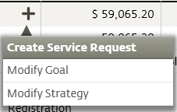

  - Choose the new model that fits in the appropriate risk category
  - Edit the fees to ensure they remain the same
- Click Generate Paperwork
- Go to the Account Allocation tab
  - Click the Gear
  - Click Select Account and select the correct account number
- Go back to the paperwork tab
  - Click the Submit Paperwork button
  - This will automatically send the paperwork to the back office for review

References

N/A

Revision History

Revision Date | Revised By | Revision Notes
11/14/2022 | Katie Weinschenk | Procedure Created

