Procedure Name: | Turn Off Billing for AMP Equity /  Mutual Fund / CD Positions
Department: | Investment Team
Effective Date: | 11/14/2022 | Author: | Katie Weinschenk

Description

Use the following procedure when we wish to exclude a non-cash position from billing in an AMP account.

Assumptions

N/A

Procedure

- In WMP, pull up the account you wish to exclude from billing
- Click on the Billing Tab
- Click on the Billing Group Name hyperlink
- Under the correct account number, click View Fee Schedule
- Click the Client Fee link

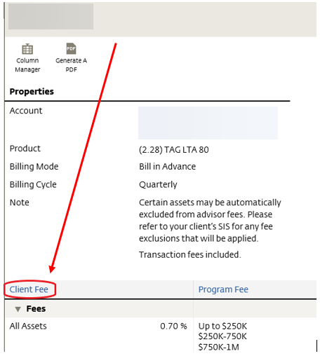

- Click the + Add on the top of the screen and select Asset Category

- On the following screen, you will complete the following:
  - Securities (Ticker or CUSIP)
  - % of holding: 100
  - End Date: BLANK
  - Description: TICKER Billing Exclusion
  - Comment: Per rep, exclude from billing on account

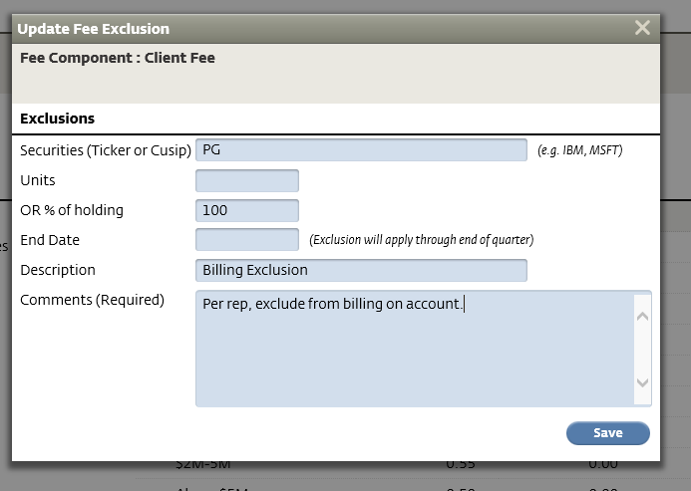

- Click Save
- You can confirm the cash exclusion is on an account on the Client Fee page under Exclusions

References

N/A

Revision History

Revision Date | Revised By | Revision Notes
11/14/2022 | Katie Weinschenk | Procedure Created

