pProcedure Name: | Remove Security Restrictions  (Advisor Model Portfolio)
Department: | Investment Team
Effective Date: | 11/14/2022 | Author: | Katie Weinschenk

Description

When a restriction can be lifted in order to trade the fund in the account, we will follow these instructions to remove the security restriction.

Assumptions

N/A

Procedure

- From the Wealth Management Platform, search for the account in question
- From the Service tab, click on the hyperlinked account number
- Click on the Controls screen
- All Restrictions will appear in the Account Restrictions area
- To remove the restriction,
  - Click on the gear next to the ticker symbol

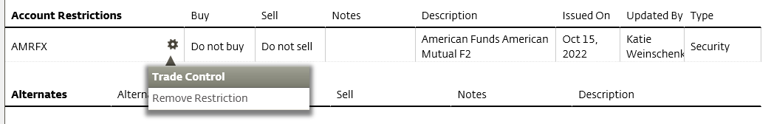

  - Click on Remove Restriction
  - Select Yes to confirm you wish to delete the trade restriction
- The restriction will no longer appear in the Controls tab

References

N/A

Revision History

Revision Date | Revised By | Revision Notes
11/14/2022 | Katie Weinschenk | Procedure Created

