Procedure Name: | WMP Household Update
Department: | Investment Team
Effective Date: | 11/14/2022 | Author: | Katie Weinschenk

Description

When setting up WMP accounts, we need to make some household updates to ensure everything is titled correctly and will produce accurate reporting.

Assumptions

N/A

Procedure

- Household Title & Benchmarks
  - In WMP, click on the magnifying glass in the upper right-hand corner
  - Search for the client by last name in the left box and choose Client in the right box

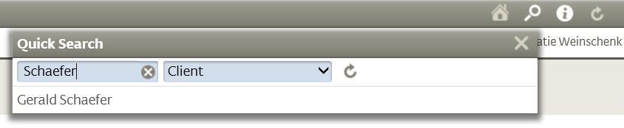

  - Select the correct client
  - Go to the General tab and click Edit

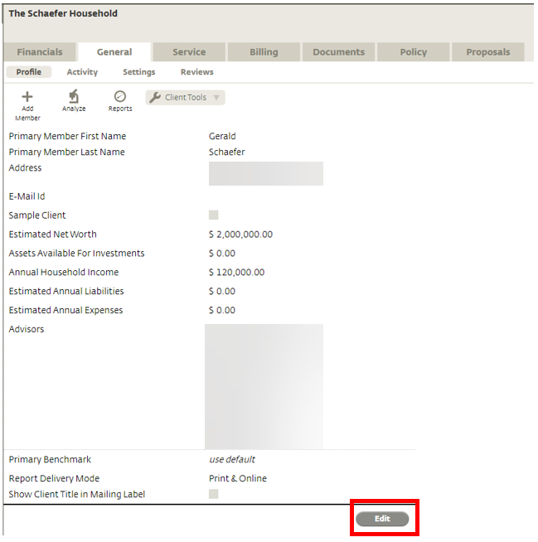

  - The following screen will appear:

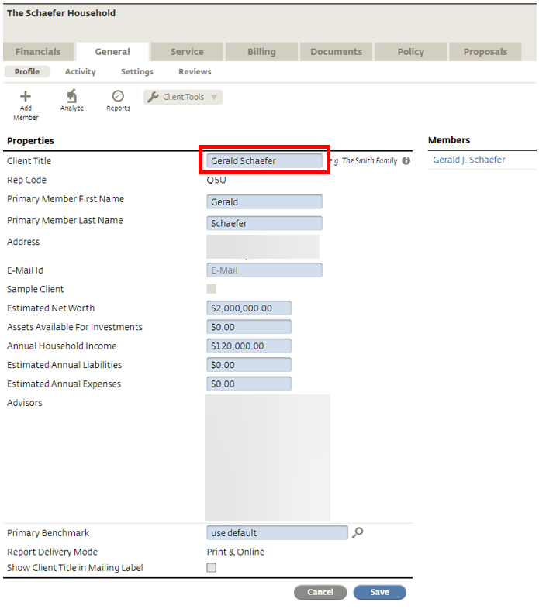

    - Change the client title to match the format: FirstName1 and FirstName2 LastName.
      - For example, for clients John Smith and Mary Smith, the title would read “John and Mary Smith”

  - On the same screen, update the benchmark to None

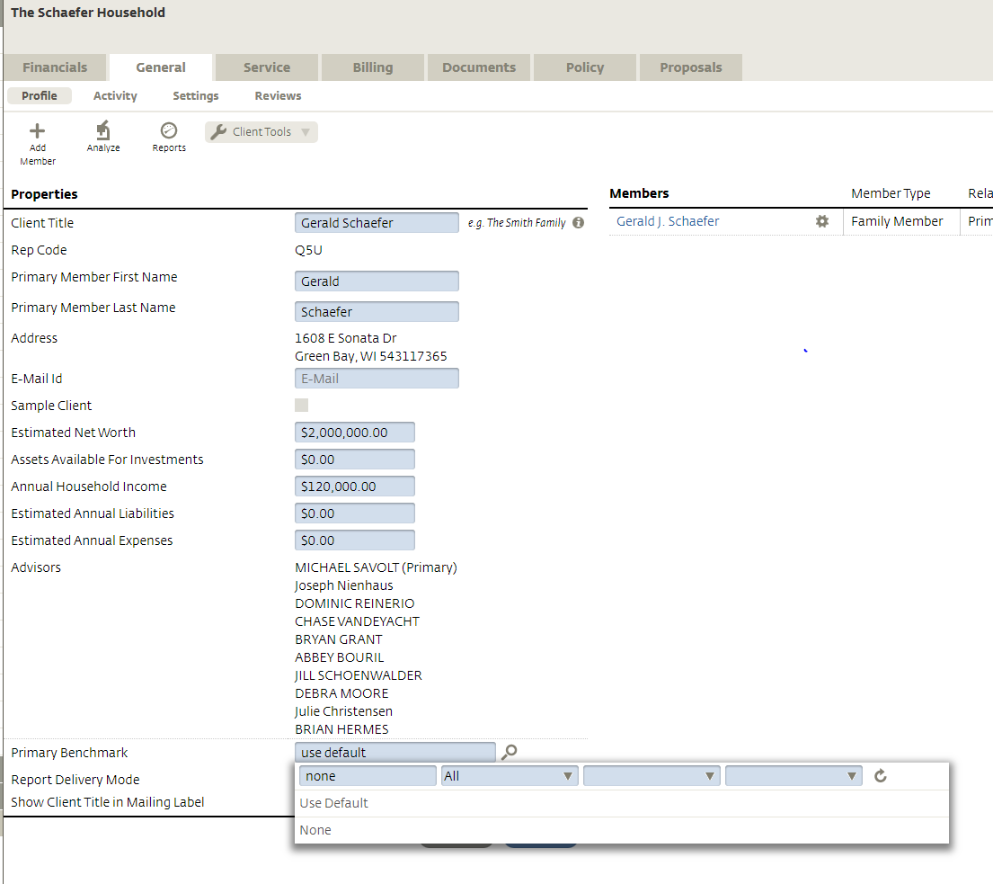

    - Click the magnifying glass next to the Primary Benchmark
    - Delete Use Default and type “None” into the box
    - Click the search icon and select None from the dropdown menu
  - Click Save. The Primary Benchmark line should state Do Not Show Benchmarks
- Go to the Financials tab

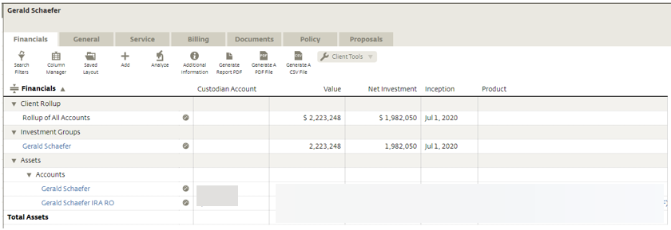

  - Make sure accounts are titled to match the format: FirstName LastName AccountType
    - For example, John Smith IRA.
  - Account Types:
    - IRA
    - IRA RO
    - IRA Beneficiary
    - IRA Roth
    - IRA Roth Beneficiary
    - Individual
    - TOD
    - JTWROS
    - JT TOD
    - Trust
    - UTMA FBO Child’s Name
  - If the titles are not correct, click on each account name

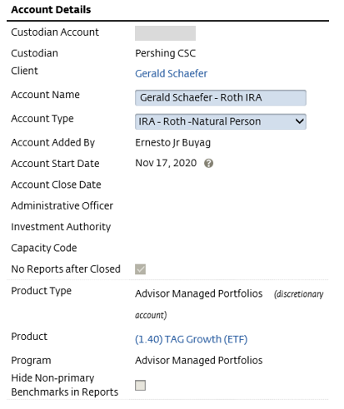

    - Select Edit
    - Type the correct title in the Account Name box
    - Click Save

References

N/A

Revision History

Revision Date | Revised By | Revision Notes
11/14/2022 | Katie Weinschenk | Procedure Created

