Procedure Name: | DST Vision
Department: | Investment Team
Effective Date: | 11/14/2022 | Author: | Katie Weinschenk

Description

DST Vision is a website that aggregates many direct mutual fund and annuity company client information in one place for each advisor.

Assumptions

N/A

Procedure

- To access DST Vision, you will log in under the representatives ID and Password
- This is a good tool to review direct client accounts, statements, bank information, beneficiary designations, distribution & contribution information, et cetera
- Daily Check
  - From the home screen, click on the Client tab
  - If you are the first person to access the Client tab for the day, you will see a list of the previous day’s transactions
  - If the recent transaction list does not automatically populate, you can click on the Recent Transactions tab

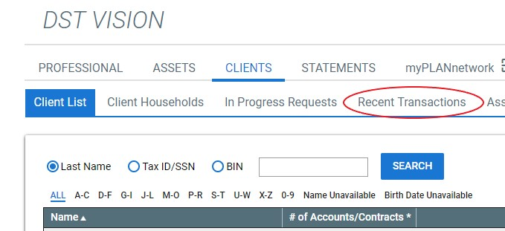

  - This is a good tool for reviewing expected (or unexpected) transactions related to a follow-up task
- Adding Rep Code Access
  - Click Administrative in the right-hand corner

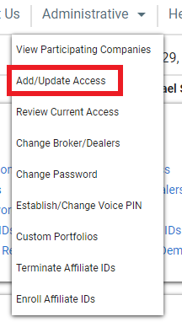

  - Select Add/Update Access
  - Review the current fund company and rep codes DST can access
  - Click Continue
  - On the following screen, search for the fund companies you wish to add access to

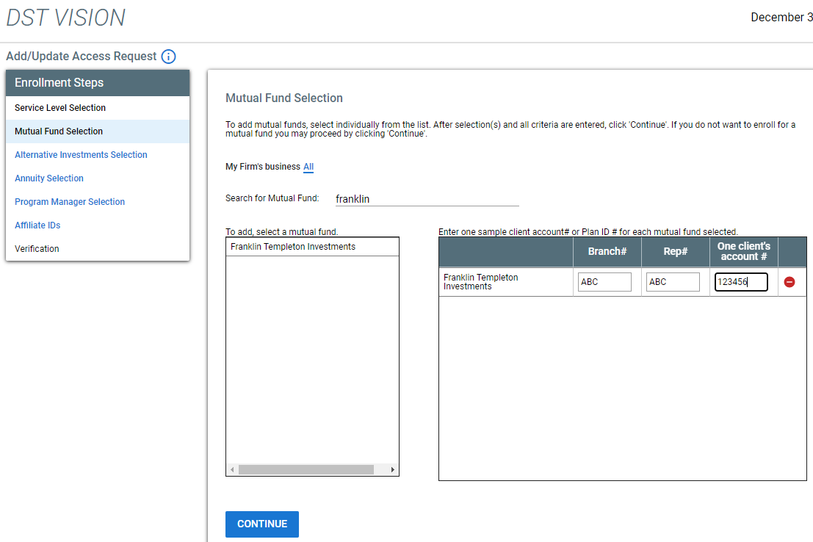

    - You will need one client account number under the rep ID you wish to add
    - Continue to add fund companies and rep ID numbers until you are finished
    - Click Continue
  - An email will be sent to the rep when access has been added or denied

References

N/A

Revision History

Revision Date | Revised By | Revision Notes
11/14/2022 | Katie Weinschenk | Procedure Created

