Procedure Name: | Missing Cost Basis
Department: | Investment Team
Effective Date: | 11/14/2022 | Author: | Katie Weinschenk

Description

Cost basis is the original value or purchase price of an asset or investment for tax purposes. The cost basis value is used in the calculation of capital gains or losses, which is the difference between the selling price and purchase price. When cost basis is missing for a Pershing account and we have the information available, you may enter the cost basis information in NetX.

Assumptions

N/A

Procedure

- In NetX, pull up the account you need to enter missing cost basis
- Click on the Holdings tab
- Click Cost Basis Maintenance

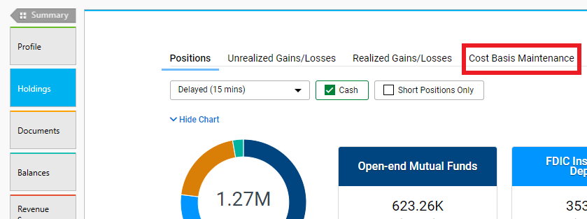

- In the Cost Basis Maintenance Screen, click the Unit Cost/Price hyperlink next to the security or mutual fund you need to enter cost basis

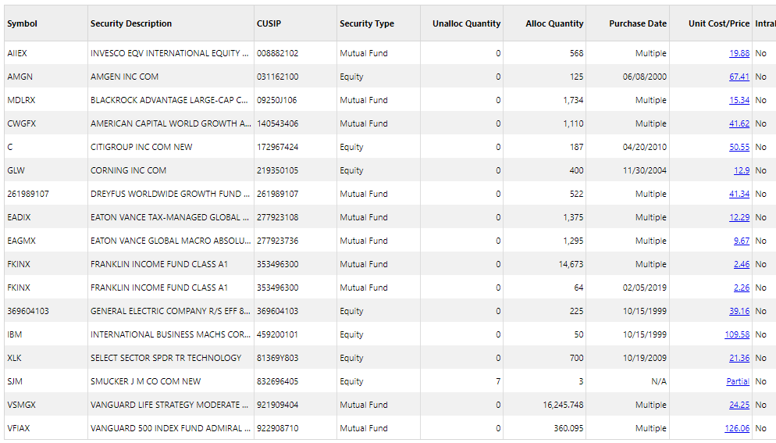

- The position’s Cost Basis Maintenance screen will pull up. It will tell you how many shares are allocated and how many shares are unallocated as well as provide space to enter in cost basis information about the unallocated shares

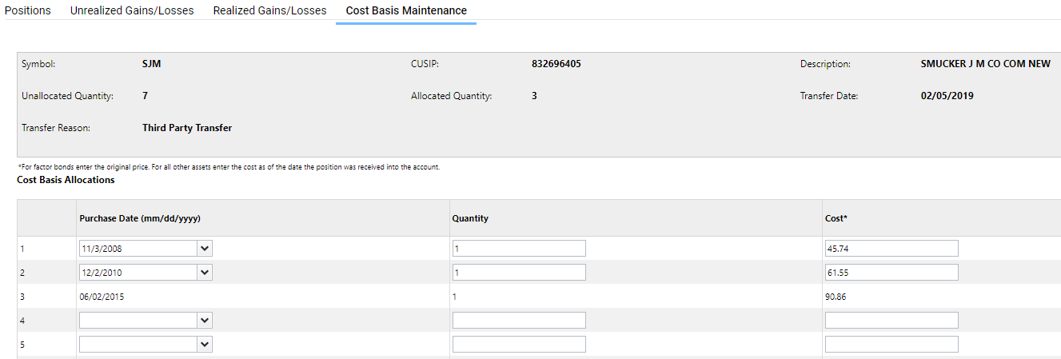

- Once you’ve entered your cost basis allocations, click Save
- The cost basis will automatically update on the Cost Basis Maintenance screen

References

N/A

Revision History

Revision Date | Revised By | Revision Notes
11/14/2022 | Katie Weinschenk | Procedure Created

