Procedure Name: | Mobile Deposit
Department: | Investment Team
Effective Date: | 11/14/2022 | Author: | Katie Weinschenk

Description

When a check is received for a Pershing account, it can be deposited through the NetX app.

Assumptions

N/A

Procedure

- Login to NetX Mobile
- Scroll down and click on the Deposit icon

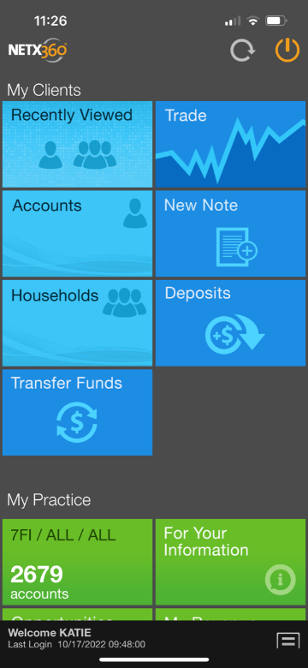

- This will bring up the Check Deposit screen

(check image will appear but omitted from screenshot)
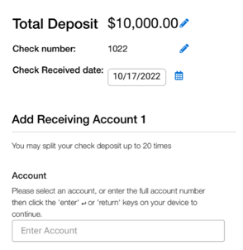

  - Take photos of the front and back of the check
  - The Total Deposit amount will populate from the check image
    - If the amount is incorrect, click the pencil icon next to the amount and edit
  - The check number will populate from the check image
    - If the check number is incorrect, click the pencil icon next to the number and edit
  - The Check Received date will auto populate
- On the Add Receiving Account section of the screen

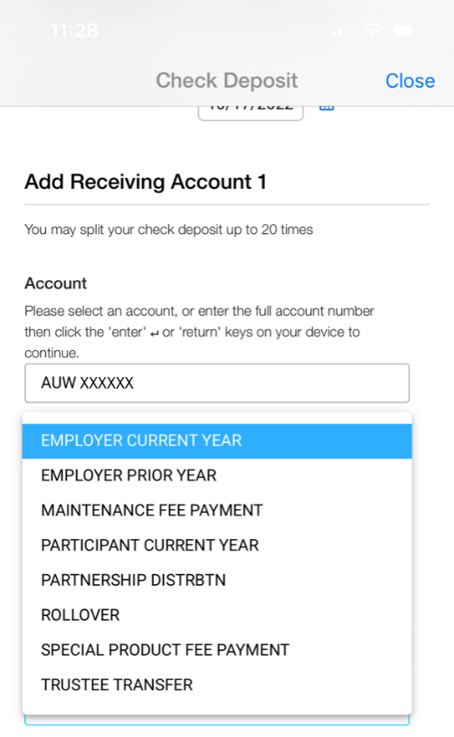

  - Type in the Account Number
  - Select the appropriate Deposit Reason
  - Click Review
- Review the information for accuracy and if you find everything to be correct, click Submit. If changes are necessary, click Edit to correct the information

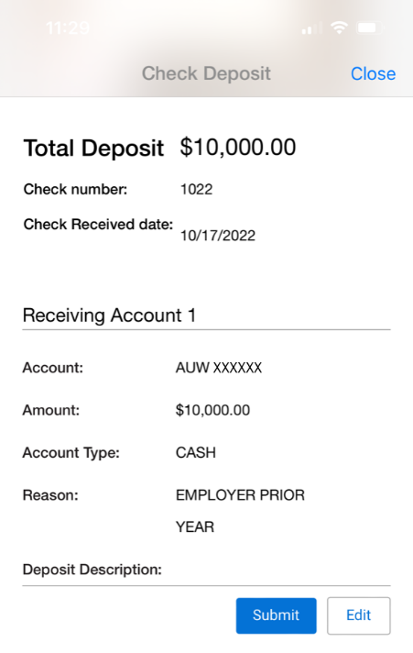

- A confirmation screen will pop up

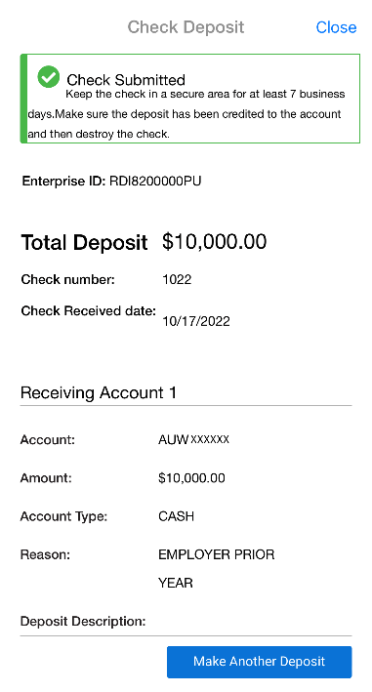

- You will need to scroll up to obtain the Enterprise ID. This is your confirmation number which you will need in the next step and for blottering in V2020
- Write down the date, your initials, and the Enterprise ID. Scan this information with a copy of the check and save it in both the Check Blotter file and the client’s account file

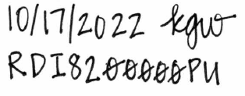

- Information to keep in mind:
  - Remember that the check needs to be logged on the Woodbury website and a copy of the check need to be placed in the client’s account file as well as the Check Blotter file
  - Put a task in Redtail to confirm the deposit was received and invested into the account
  - If Mobile Deposit is down and you need to mail a check to Pershing:
    - Overnight Mail:
Pershing LLC
Attn: 382121
500 Ross Street 154-0455
Pittsburgh, PA 15262-0001
  - Woodbury prohibits financial professionals from accepting or attempting to make deposits of:
    - US or Foreign cash or currency
    - Money orders
    - Traveler’s checks
    - Checks drawn on a foreign bank
    - Checks made payable to Tax Management Services
    - Checks made payable to Cash
    - Checks made payable to a financial professional
    - Checks denominated in a currency other than US Dollars
    - Starter Checks
    - Cashier checks under $10,000.00
    - Checks already deposited that have been returned by a bank for insufficient funds. The check will not be re-deposited and needs to be replaced with wired funds.

References

N/A

Revision History

Revision Date | Revised By | Revision Notes
11/14/2022 | Katie Weinschenk | Procedure Created

