Procedure Name: | One-Time Contribution
Department: | Investment Team
Effective Date: | 11/14/2022 | Author: | Katie Weinschenk

Description

When a client wishes to make a one-time contribution from their bank account to a Pershing account, we can pull the money in through NetX.

Assumptions

N/A

Procedure

- If the client does not have a bank account on file, complete an ACH Authorization
  - Obtain client e-signature or physical signature
  - If form is physically signed, upload paperwork to NetX
- Go to the correct account in NetX
- Click on the Profile tab
  - Click on Standing Instructions

  - From the drop-down menu next to the bank account, click the Action Links dropdown

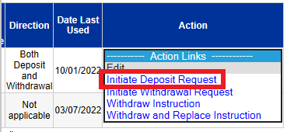

    - Click Initiate Deposit Request

  - On the next screen, complete the following:

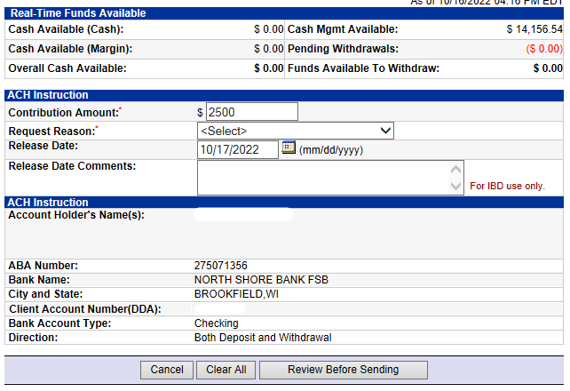

    - Contribution Amount
    - Request Reason
      - Maintenance Fee Payment
      - Participant Current Year
      - Participant Prior Year
      - Rollover
      - Termination Fee Payment
    - Release Date: date to pull money from bank account
    - Review the ACH Instructions
    - Click Review Before Sending
  - Reconfirm all information regarding the request
  - If everything is correct, click Send ACH Request

  - Create a reminder in Redtail to confirm the contribution has occurred
  - Once the contribution is pulled into the account, request the funds be invested in the model by entering a 03 – ADV INVEST ACCOUNT(S) IN MODEL activity in Redtail
  - Confirm investment

References

N/A

Revision History

Revision Date | Revised By | Revision Notes
11/14/2022 | Katie Weinschenk | Procedure Created

