Procedure Name: | NetX Items for Attention
Department: | Investment Team
Effective Date: | 11/14/2022 | Author: | Katie Weinschenk

Description

Items for Attention (IFA) summarizes all open items for Pershing accounts in NetX.

Assumptions

N/A

Procedure

- From the NetX home screen, you will see Items for Attention

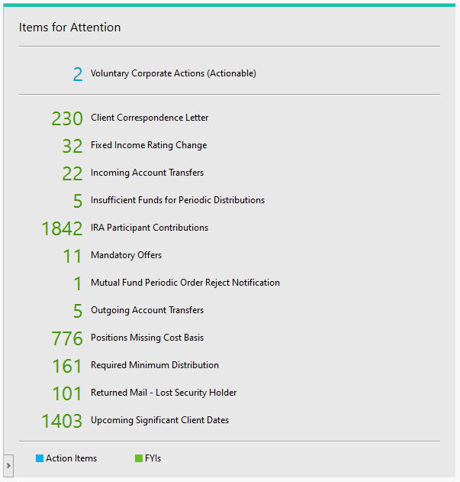

  - Click into Items for Attention and review the notifications
- Some of the Items for Attention include:
  - Margin Details: list of accounts that hold a debit that must be satisfied immediately
  - Voluntary Offers: display reorganization announcements for securities in which you have positions, where the client may choose to opt in or out. Offers are determined by the company and details set by the transfer agent.
    - To participate in the offer:
      - Enter a specific number of shares or bid into the respective fields.
      - Select the All-Eligible checkbox to participate for all shares.
      - Select the checkbox stating Participating in the Offer for all accounts and for all eligible quantity along the top of the screen.
    - To decline the offer:
      - Select the Decline checkbox next to specific accounts.
      - Select the checkbox stating Decline the Offer for all accounts on this page along the top of the screen.
    - Click Submit Instructions and a verification window will display prompting you for one of the following:
      - Send: the instructions will be submitted
      - Modify: update the instructions
      - Clear: cancel the instructions
    - Users must have proper credentials to submit the offers
  - Incoming Account Transfers: information on account assets that are transferring into Pershing or between two Pershing accounts, from the initial submission through the completion of the transfer (includes ACAT, non-ACAT, internal transfer, mutual fund transfer)
  - Outgoing Account Transfers: information on account assets that are transferring out of Pershing or between two Pershing accounts from the initial submission through the completion of transfer (includes ACAT, non-ACAT, and internal transfers).
  - Mandatory Offers: summary of accounts that have been issued a mandatory reorganization offer. Unlike Voluntary Offers, you can only view the announcements.
  - Physical Securities Pending Documentation: link to specific stock certificates in “pending papers” status (due to a missing death certificate, affidavit of domicile, restricted stock paperwork, etc.) This is for viewing purposes only.
  - IRA Participant Contributions: information on accounts that have not maximized their IRA contributions for the current and prior tax years.
  - Insufficient Funds for Periodic Distributions: displays a list of retail and retirement accounts that will not have sufficient funds to meet future systematic and periodic distributions.
  - Required Minimum Distributions: view and monitor RMDs for retirement accounts.
  - Good ‘Til Cancel Expiring Orders: provides a summary of accounts that have outstanding GTC orders that will expire within the next ten (10) business days.
  - Revised 1099s: provides a view and a way to monitor a 1099 revision that has been issued on client accounts. Info only populated during tax season.
  - ACH Rejected by Bank: provides a list of ACH instructions that were rejected by the bank.
  - Positions Missing Cost Basis: displays accounts where cost basis has been established on the account but the initial purchase price information is missing.

References

N/A

Revision History

Revision Date | Revised By | Revision Notes
11/14/2022 | Katie Weinschenk | Procedure Created

