Procedure Name: | Turn Off Billing for AMP Cash Positions
Department: | Investment Team
Effective Date: | 11/14/2022 | Author: | Katie Weinschenk

Description

Use the following procedure when we wish to exclude a cash position from billing in an AMP account.

Assumptions

N/A

Procedure

- In WMP, pull up the account you wish to exclude from billing
- Click on the Billing Tab
- Click on the Billing Group Name hyperlink
- Under the correct account number, click View Fee Schedule
- Click the Client Fee link

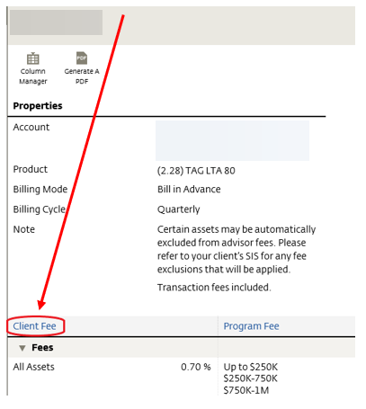

- Click the + Add on the top of the screen and select Asset Category
- On the following screen, you will complete the following:

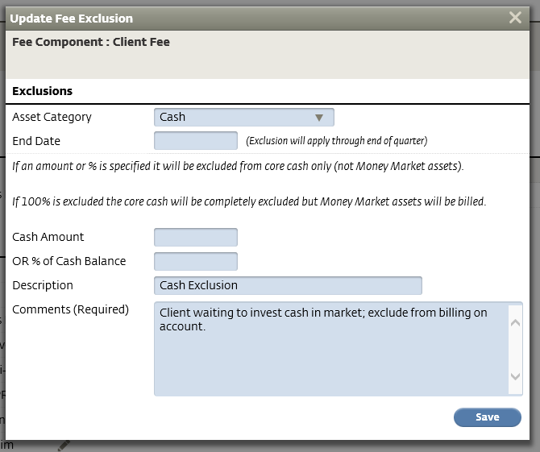

  - Asset Category: Cash
  - End Date: BLANK
  - Cash Amount: BLANK
  - % of Cash Balance: BLANK
  - Description: Cash Exclusion
  - Comment: Client waiting to invest in mark; exclude from billing on account
- Click Save
- You can confirm the cash exclusion is on an account on the Client Fee page under Exclusions

References

N/A

Revision History

Revision Date | Revised By | Revision Notes
11/14/2022 | Katie Weinschenk | Procedure Created

